WINDTHORST INDEPENDENT SCHOOL DISTRICT
SPECIAL EDUCATION OPERATING PROCEDURES

WINDTHORST ISD has entered into an Interlocal Agreement to cooperatively operate its special education programs under the authority of Tex. Ed. Code § 11.157. The Big 4 Shared Services Arrangement may provide for the efficient delivery of legally required special education and related services to the WINDTHORST ISD’s eligible students with disabilities as set forth in the Interlocal Agreement, including the implementation of these Special Education Operating Procedures.

2.0 EVALUATIONS

2.1 What is the primary purpose of a full individual and initial evaluation?
2.2 Who can provide informed written consent for a full individual and initial evaluation?
2.3 What will be included in a prior written notice (Notice of Proposed Evaluation) for a full individual and initial evaluation?
2.4 What is the timeline for the completion of a full individual and initial evaluation?
2.5 How does the District provide notice of evaluation and seek consent?
2.6 How does the District conduct a full individual and initial evaluation?
2.7 What additional procedures are required for identifying students with specific learning disabilities?
2.8 How is eligibility determined following a full initial and individual evaluation?
2.9 What are the procedures for conducting a review of existing educational data (REED) as part of an initial evaluation (if appropriate) and any reevaluation?
2.10 When and how are reevaluations conducted?
2.11 What is the timeline for a reevaluation?
2.12 What is the process for conducting an evaluation before a student may no longer be eligible for special education and related services?
2.13 How does the District respond when it receives a request for an independent educational evaluation (IEE)?

2.14 EVALUATIONS SUPPLEMENT—AREAS OF ELIGIBILITY
AUTISM
DEAF-BLINDNESS
DEAF OR HARD OF HEARING
EMOTIONAL DISTURBANCE
INTELLECTUAL DISABILITY
MULTIPLE DISABILITIES
ORTHOPEDIC IMPAIRMENT
OTHER HEALTH IMPAIRMENT
SPECIFIC LEARNING DISABILITY
SPEECH OR LANGUAGE IMPAIRMENT
TRAUMATIC BRAIN INJURY
VISUAL IMPAIRMENT
NONCATEGORICAL EARLY CHILDHOOD
FOR MORE INFORMATION ABOUT EACH AREA OF ELIGIBILITY

WINDTHORST ISD Board Policy along with these Special Education Operating Procedures constitute the Policies and Procedures of WINDTHORST ISD which are designed to be consistent with the State policies and procedures developed pursuant to the IDEA. WINDTHORST ISD Special Education Operating Procedures do not and are not intended to create a requirement that is not otherwise imposed by the Individuals with Disabilities Education Improvement Act (“IDEA”), together with its implementing federal regulations, state statutes and rules, as they shall from time to time be amended, and shall not be construed to create a higher standard than that established by IDEA. These Special Education Operating Procedures will be posted on WINDTHORST ISD’s website. These Special Education Operating Procedures should be interpreted consistent with the IDEA. WINDTHORST ISD’s Special Education Operating Procedures are reviewed and updated, as needed, on at least an annual basis. WINDTHORST ISD will make timely changes to policies and procedures in response to IDEA amendments, regulatory or rule changes, changes to state policy, or new legal interpretation as are necessary to bring WINDTHORST ISD into compliance with the requirements of IDEA. WINDTHORST ISD maintains systems to ensure that all students with disabilities residing in the District, including students with disabilities attending non-public schools, regardless of the severity of their disabilities, and who are in need of special education and related services, are identified, located, and evaluated and provided a free appropriate public education. WINDTHORST ISD maintains systems to ensure that students with disabilities and their parents or guardians are afforded the procedural safeguards required under the IDEA (and its implementing federal regulations, state statutes and rules), including with respect to the confidentiality of records and personally identifiable information.

2.0 EVALUATIONS

2.1 What is the primary purpose of a full individual and initial evaluation?

The purpose of the full individual and initial evaluation is to:

- determine if a student meets the criteria for having one of the categories of disability referenced in Section 1.2: CHILD FIND;

- determine if, by reason of the disability, the student needs special education and related services, and therefore qualifies for special education and related services; and

- determine the educational needs of the student.

Evaluations will provide information to determine present levels of academic achievement, social
and emotional performance, and related educational needs. No single evaluation tool may be used as the sole criterion for determining eligibility. Rather, a variety of assessments (both formal and informal assessments), including information provided by parents, guardians, classroom teachers, and observations of the student classroom performance, work samples/portfolios, interviews, and review of the records used.

2.2 Who can provide informed written consent for a full individual and initial evaluation?

Informed written consent for an initial evaluation for special education and related services is provided by a student’s parent, and that term is defined broadly.

Texas law defines “parent” as “a person standing in parental relation,” but does not “include a person as to whom the parent-student relationship has been terminated or a person not entitled to possession of or access to a child under a court order.”

The IDEA defines the term “parent” as—

- A biological or adoptive parent of a child.

- A foster parent, unless State law, regulations, or contractual obligations with a State or local entity prohibit a foster parent from acting as a parent.

- A guardian generally authorized to act as the child’s parent, or authorized to make educational decisions for the child (but not the State if the student is a ward of the State).

- An individual acting in the place of a biological or adoptive parent (including a grandparent, stepparent, or other relative) with whom the child lives, or an individual who is legally responsible for the child’s welfare.

- A surrogate parent.

When the parents of a student with a disability are divorced, the parental rights under the IDEA apply to both parents, unless a court order specifies the respective educational rights and duties of the parents.

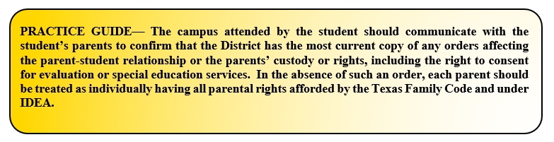

A foster parent may act as the parent of a student with a disability if the Texas Department of Family and Protective Services is appointed as the student’s temporary or permanent managing conservator and has not been limited in its rights and duties to make educational decisions by court order, and if the foster parent agrees to make educational decisions on behalf of the student and complete a special education advocacy training program. The foster parent must complete the training program before the student’s next ARD committee meeting or by no later than 90 days after the foster parent begins to act on the student’s behalf.

A student’s special education rights, including the right to grant or withhold consent for an evaluation or reevaluation, transfer from the parent or guardian to the adult student when the student turns 18.

If the District is unable to identify or locate a parent or guardian for a student with a disability, or the foster parent of the student is unwilling or unable to serve as a parent, the District will appoint someone to serve as the student’s surrogate parent. The individual appointed as surrogate parent may not be employed by the District or any other agency involved in the education or care of the student.

Additionally, the surrogate parent must:

- Be willing to serve in that capacity.

- Exercise independent judgment in pursuing the student’s interests.

- Ensure that the student’s due process rights are not violated.

- Complete a training program.

- Visit the student and the school where the student is enrolled to review the student’s educational records and consult with any person involved in the student’s education.

- Attend meetings of the student’s ARD committee.

The District will also provide notice of the surrogate parent’s appointment to the District’s homeless student liaison.

2.3 What will be included in a prior written notice (Notice of Proposed Evaluation) for a full individual and initial evaluation?

Before conducting an evaluation, the District will provide the student’s parent or guardian Prior Written Notice (Notice of Proposed Evaluation) that—

- describes the areas of evaluation that have been proposed, and descriptions of any evaluation procedures that the District proposes to conduct;

- explains why the District wants to conduct the evaluation; the options considered and why rejected; a description of each evaluation procedure, assessment, record, or report the District used as a basis for proposing to evaluate; other options to an evaluation that were considered and why those options were rejected; other factors relevant to the decision to evaluate;

- informs the parent or guardian of her or his right to refuse consent for the evaluation, together with a copy of the TEA’s Notice of Procedural Safeguards;

- is written in a form that the general public can understand. It must also be provided in the parent or guardian’s native language (or the language that they normally use, like Braille or large print type-face) unless it is clearly not feasible to do so. If the parent’s or guardian’s native language or other mode of communication is not a written language, the District will take steps to ensure—

  - that the notice is translated orally or via other means to the parent or guardian in her or his native language or other mode of communication;

  - that the parent or guardian understands the contents of the District’s Notice of Proposed Evaluation, and

  - that there is written evidence of the District’s efforts to ensure these two steps have been taken.
Also, concerning the administration of psychological assessment or tests, on request of a student’s parent or guardian, and before obtaining the parent or guardian’s consent for the administration of any psychological examination or test to the student that is included as part of the evaluation of the student’s need for special education and related services, the District will provide to the student’s parent or guardian: (1) the name and type of the examination or test; and (2) an explanation of how the examination or test will be used to develop an appropriate Individualized Education Program (IEP) for the student.
The District’s Notice of Proposed Evaluation should specify that the District plans to evaluate in each area of suspected disability. Requests by parents or guardians to limit the scope of the evaluation (such as when based on the parent or guardian’s preferences for seeking or avoiding consideration of specific eligibility categories) may not be honored when the parent or guardian’s limits on the scope of evaluation might prevent the District from completing an evaluation that complies with these Operating Procedures.

2.4 What is the timeline for the completion of a full individual and initial evaluation?

Within 45 school days of receiving written consent for the evaluation, the Big 4 SSA will complete a written report of the student’s full individual and initial evaluation. Likewise, if a student is not enrolled in the District, including students who are under the age of 5 or attending private schools within the District or are homeschooled, the District will complete the student’s evaluation report within 45 school days of the date the District receives written consent for the evaluation from the student's parent or guardian.

If, during the course of the student’s evaluation, the student has been absent from school 3 or more school days, the time to complete the evaluation may be extended by a number of school days equal to the number of school days the student was absent during the evaluation process.

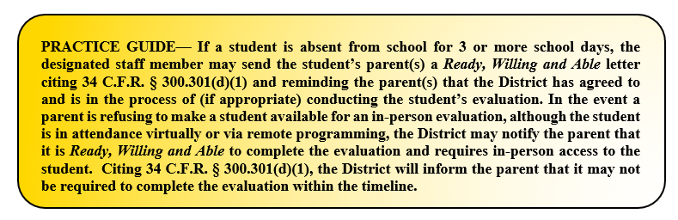

The student is considered absent for the school day if the student is not in attendance at the school's official attendance taking time or, if applicable, at the alternate attendance taking time set for that student. The student is considered in attendance if the student is off campus participating in an extracurricular or other activity approved by the District and under the supervision of a District teacher or other professional staff member or an adjunct staff member who has a minimum of a bachelor's degree and is eligible for participation in the Teacher Retirement System of Texas.

If the District receives the written consent described above at least 35, but less than 45 school days, before the last instructional day of the school year, the written evaluation of the student will be provided to the student's parent or guardian no later than June 30 of that year. The student's ARD committee will meet no later than 15 days after the start of the following school year to consider the evaluation and the student’s eligibility for special education and related services. However, the time for completion of the evaluation may be extended as described above, if the student is absent from school 3 or more days between the date the District received written consent and the last instructional day of the school year.

If an initial evaluation completed by June 30 in the manner above indicates that the student will need Extended School Year (ESY) services during the summer the evaluation is completed, the ARD committee will meet as promptly as possible to consider eligibility and ESY services.

If a student was in the process of being evaluated for special education eligibility by another school district in Texas and enrolls in the District prior to the completion of the student’s evaluation, the District will coordinate with the previous school district as necessary and as expeditiously as possible to ensure a prompt completion of the evaluation.

The 45 school day timeline and its exceptions do not apply if the District is making sufficient progress to ensure a prompt completion of the evaluation, and the student’s parent or guardian and the District agree to a specific time by which the evaluation will be completed.

The District will ensure that an IEP is in effect for a student by the student’s 3rd birthday. If a student's 3rd birthday occurs during the summer, the student's ARD committee shall determine the date when services will begin. Please see Section 3.14: FAPE.
2.5 How does the District provide notice of evaluation and seek consent?

The District’s multidisciplinary evaluation team, comprised of personnel qualified to evaluate the student in the areas specified in the referral and/or notice or by Big 4, will prepare a Notice of Proposed Evaluation as described in Section 2.3: EVALUATIONS.
The Big 4 SSA will then provide the parent or guardian with a copy of the written Notice of Proposed Evaluation and the District’s Consent for Evaluation Form. The parent or guardian will then indicate whether the parent or guardian provides consent by marking “yes” to all of the following:
- the parent or guardian has been fully informed of all information relevant to the initial evaluation in the parent or guardian's native language or other mode of communication;
- the parent or guardian understands and agrees in writing to the District carrying out the initial evaluation;
- the parent or guardian understands that the granting of consent is voluntary on the part of the parent or guardian and may be revoked at any time; and
- if the parent or guardian revokes consent, that revocation is not retroactive; therefore, it does not negate an action that has occurred after the consent was given and before the consent was revoked.
The date on which the District receives the form with each of these items marked “yes” will be day zero for calculating the timeline for completing the evaluation.
In the event the parent or guardian requested information about certain psychological examinations, before providing consent as discussed in Section 2.3: EVALUATIONS, and the District later determines that an additional examination or test is required for the evaluation of the student’s need for special education, the Big 4 SSA shall provide to the parent or guardian (1) the name of the examination or test and (2) an explanation of the additional examination or test that will be used to develop an appropriate IEP, and shall obtain additional consent for the examination or test. The time required for the District to provide information and seek consent concerning the additional examination or test may not be counted toward the timeline for completion of an evaluation. If a parent or guardian does not give consent for the additional examination or test within 20 calendar days after the date the District provided to the parent the information required here, the parent or guardian's consent is considered denied.
The District has the right to conduct an evaluation or reevaluation if the District has reason to suspect that a student has a disability and that by virtue of the suspected disability needs specially designed instruction. If the parent or guardian refuses consent for the District-proposed evaluation or reevaluation, the District may seek to override parental or guardian refusal to consent by filing for a special education due process hearing.
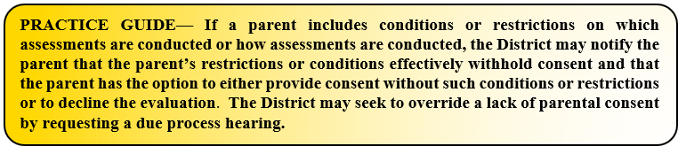

2.6 How does the District conduct a full individual and initial evaluation?

When conducting a student’s full individual and initial evaluation, the District will—

- use a variety of assessment tools and strategies to gather relevant functional, developmental, and academic information about the student to assist in determining the student’s eligibility and developing the content of the student’s IEP (discussed in Section 3.3: FAPE);

- not use any single measure or assessment as the sole criterion for its eligibility determination;

- use technically sound instruments that may assess the relative contribution of cognitive, behavioral, physical or developmental factors;

- select and administer assessments, particularly to a student with impaired sensory, manual or speaking skills, that will best ensure those assessments accurately reflect the student’s aptitude or achievement level (or whatever other factors the test purports to measure), rather than reflecting the student’s impaired sensory, manual, or speaking skills (unless those skills are the targets of the test).

The student will be evaluated in all areas related to the student’s suspected disabilities in order to assess the student’s eligibility for special education and related services, including, if appropriate health, vision, hearing, social and emotional status, general intelligence, academic performance, communicative status, and motor abilities. Consequently, the assessments and evaluative instruments should be tailored to the student’s suspected disabilities and conducted in all areas related to the student’s suspected disabilities. However, the District will ensure that the evaluation is sufficiently comprehensive to identify all of the student’s special education and related services needs, whether or not the assessments used are commonly linked to the student’s suspected disability categories.

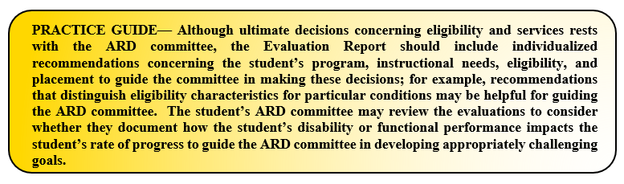

Additionally, the District will ensure that the assessments and other evaluation materials used to conduct a full individual and initial evaluation—

- are selected and administered in a way that is not racially or culturally discriminatory;

- are provided and administered in the student's native language or other mode of communication and in the form most likely to yield accurate information on what the student knows and can do academically, developmentally, and functionally, unless it is clearly not feasible to so provide or administer;

- are used for the purposes for which the assessments or measures are valid and reliable;

- are administered by trained and knowledgeable personnel; and

- are administered in accordance with any instructions provided by the producer of the assessments.

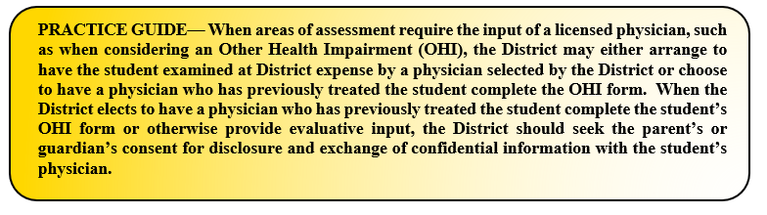

2.7 What additional procedures are required for identifying students with specific learning disabilities?

Prior to conducting an initial evaluation of a student suspected of having a specific learning disability, in order to ensure that underachievement in a student suspected of having a specific learning disability is not due to lack of appropriate instruction in reading or mathematics, the Big 4 SSA will consider the following:

- Data that demonstrates the student was provided appropriate instruction in reading and/or mathematics within general education settings delivered by qualified personnel.

- Data-based documentation of repeated assessments of achievement at reasonable intervals, reflecting formal evaluation of student progress during instruction, which must be provided to the student’s parents.

  - Documentation of the repeated assessments may include RtI progress monitoring data, in-class tests on grade-level curriculum, or other regularly administered District or classroom assessments. Intervals are considered reasonable if consistent with the assessment requirements of a student's specific instructional program.

In order to qualify as a student with a specific learning disability (SLD), the student—

- has been determined through a variety of assessment tools and strategies to meet the criteria for a specific learning disability; and

- does not achieve adequately for the student's age or meet state-approved grade-level standards in oral expression, listening comprehension, written expression, basic reading skill, reading fluency skills, reading comprehension, mathematics calculation, or mathematics problem solving when provided with learning experiences and instruction appropriate for the student’s age or state-approved grade-level standards, as indicated by performance on multiple measures such as in-class tests; grade average over time (e.g. six weeks, semester); norm- or criterion-referenced tests; and statewide assessments.

Also, the student must either—

- not make sufficient progress to meet age or state-approved grade-level standards in oral expression, listening comprehension, written expression, basic reading skill, reading fluency skills, reading comprehension, mathematics calculation, or mathematics problem solving when provided a process based on the student's response to evidence-based intervention; or

- exhibit a pattern of strengths and weaknesses in performance, achievement, or both relative to age, state-approved grade-level standards, or intellectual development that is determined to be relevant to the identification of a specific learning disability, using appropriate assessments.

If a student is found to qualify as a student with a SLD, it cannot be primarily the result of: a visual, hearing, or motor disability; an intellectual disability; emotional disturbance; cultural factors; environmental or economic disadvantage; or due to the student being an emergent bilingual student.

When considering a student for eligibility as a student with a specific learning disability, the multi-disciplinary evaluation team must:

- use information from an observation in routine classroom instruction and monitoring of the student's performance that was done before the student was referred for an evaluation; or

- have at least one member of the multi-disciplinary team conduct an observation of the student's academic performance in the regular classroom after parental consent has been obtained.

If a student is less than school age or out of school, a member of the multi-disciplinary team must observe the student in an environment appropriate for a student of that age.
The determination of whether a student suspected of having a SLD is a student with a disability must be made by a team consisting of:
- the student’s parents;
- at least one person qualified to conduct individual diagnostic examinations of children, including:
  - a licensed specialist in school psychology;
  - an educational diagnostician;
  - a speech language pathologist; or
  - a remedial learning teacher; and
- the student’s regular teacher.
If the student does not have a regular teacher, a regular classroom teacher qualified to teach a student of his or her age is required. If the student is younger than school age, an individual qualified by the TEA to teach a student of his or her age.

2.8 How is eligibility determined following a full initial and individual evaluation?

To be eligible for special education and related services, a student will (1) have a qualifying disability and (2) by reason thereof need special education and related services.

- Special education means “specially designed instruction, at no cost to the parents, to meet the unique needs of a [student] with a disability.” Specially designed instruction means—

  - “adapting, as appropriate to the needs of an eligible [student] under this part, the content, methodology, or delivery of instruction-

    - To address the unique needs of the student that result from the student's disability; and

    - To ensure access of the student to the general curriculum, so that the student can meet the educational standards within the jurisdiction of the public agency that apply to all students.”

The general curriculum and educational standards that “apply to all [students]” in WINDTHORST ISD are the Texas Essential Knowledge and Skills (TEKS) as well as the District’s Policy EIE(Local). The state-wide assessments that determine a student’s progress toward meeting those educational standards are the State of Texas Assessments of Academic Readiness (STAAR).

The student will not be determined to be eligible for special education and related services if the determinant factor for the determination is-

- lack of appropriate instruction in reading, including the essential components of reading instruction;

- lack of appropriate instruction in math;

- limited English proficiency, or

- if the student does not meet the criteria for one of the eligibility categories set out in Section 1.2: CHILD FIND.

Within 30 calendar days of the completion of the student’s full initial and individual evaluation report, the student’s ARD committee will meet to determine whether the student is eligible for special education and related services and, if the student is determined to be eligible, the ARD committee shall develop the student’s individualized education program (IEP). However, if the 30th calendar day falls during the summer and school is not in session, the ARD committee may wait until the first day of the following school year to finalize any decision regarding the student’s initial eligibility, IEP and/or educational placement, unless the student’s initial evaluation indicates that he or she will need extended school year services during the intervening summer.

The campus will provide a parent with a free copy of the evaluation report.

2.9 What are the procedures for conducting a review of existing evaluation data (REED) as part of an initial evaluation (if appropriate) and any reevaluation?

As part of an initial evaluation, if appropriate, and as part of any reevaluation, relevant members of the student’s ARD committee, together with any additional relevant professional staff, if necessary, will review the student’s existing evaluation data, including:
- evaluations and information provided by the student’s parent or guardian;

- current classroom-based, District or State assessments, and classroom­based observations of the student; and

- observations by teachers and related services providers.

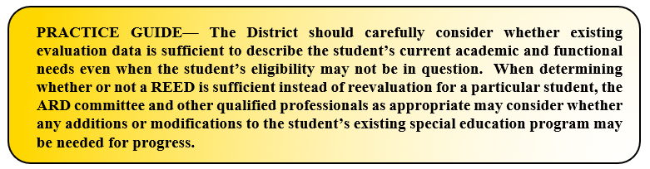
On the basis of that review, as well as input from the student’s parent(s) or guardian(s), the student’s ARD committee will identify what additional assessment or evaluations, if any, are needed to determine: (1) whether the student is or remains a student with a disability, including on the basis of having 1 or more additional as of yet unidentified suspected disabilities; (2) whether the student needs or continues to need special education and related services; (3) the educational needs of the student, including the student’s present levels of academic achievement and related developmental needs; and (4) whether any additions or modifications to the special education and related services are needed to enable the student to meet the measurable annual goals set out in the IEP of the student and to participate, as appropriate, in the general education curriculum.

The group conducting the REED may conduct the review without a formal meeting of the student’s ARD committee.
If the student’s ARD committee, including the parent or guardian, determine that no additional data (including in a new assessment area) are needed to determine whether the student is or continues to be a student with a disability, and to determine the student’s educational needs, the District will notify the student’s parents or guardians about:
- the determination and the basis for the ARD committee’s determination, and

- their right to request an assessment to determine whether the student continues to be a student with a disability and to determine the student’s educational needs.

Informed parental consent is not required before conducting a REED as part of an initial evaluation or a reevaluation. Likewise, informed parental consent is not needed when the District is administering a test or other evaluation that is administered to all students unless consent is required for all students.

2.10 When and how are reevaluations conducted?

The District will ensure that a reevaluation of a student with a disability is conducted if—

- the District determines that the educational or related services needs, including improved academic achievement and functional performance, of the student, warrant a reevaluation, or

- the student’s parent, guardian or teacher requests a reevaluation.

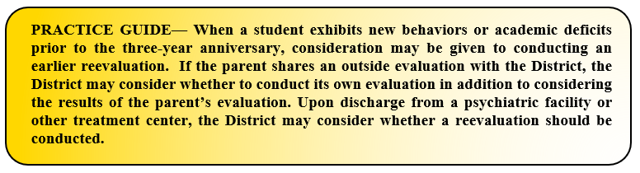
A reevaluation will be conducted at least every three-years unless the parent or guardian and the District maintains it is not necessary. A reevaluation can only occur once a year unless the parent or guardian and the District agree otherwise.

The District will obtain informed parental consent prior to conducting any reevaluation; however, the evaluation may be completed without the parent or guardian’s consent if the District can demonstrate that it made reasonable efforts to obtain informed parental consent and the student’s parent or guardian has failed to respond.

The District’s reevaluation of a student with a disability begins with a REED as outlined in Section 2.8: EVALUATIONS. The District’s reevaluation of a student with a disability should meet the requirements outlined in Section 2.5: EVALUATIONS above, but the reevaluation is not required to be identical to the student’s initial evaluation for special education and related services.

2.11 What is the timeline for a reevaluation?
Both state and federal law are silent as to how long the District has to complete a reevaluation other than “at least once every three years,” so the reevaluation will be completed by the three-year anniversary date, unless the ARD committee has agreed to complete it sooner. The parent or guardian and the District may also agree to conduct a REED in lieu of a reevaluation.
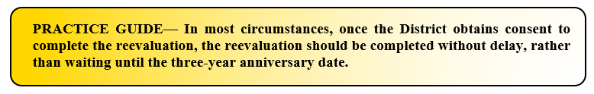
A reevaluation must occur at least once every three years, unless the parent or guardian and the District agree that a reevaluation is unnecessary. 34 C.F.R. § 300.303(b)(2). The U.S. Department of Education “acknowledges that, during the pandemic, social distancing measures and each child's individual disability-related needs may make administering some in-person evaluations impracticable and may place limitations on how evaluations and reevaluations are conducted” pursuant to IDEA and these Operating Procedures.

2.12 What is the process for conducting an evaluation before a student may no longer be eligible for special education and related services?

Before determining that a student is no longer eligible for special education and related services, the District will complete a full and individual evaluation of the student. However, no reevaluation is required if the student’s special education rights have been terminated due to graduation from high school with a regular diploma or due to exceeding the age eligibility for FAPE under State law. If a student’s right to special education has been terminated due to age or graduation with a regular high school diploma, the District will provide the student with a summary of the student’s academic achievement and functional performance, including recommendations about assisting the student in meeting postsecondary goals.

2.13 How does the District respond when it receives a request for an independent educational evaluation (IEE)?

If a parent or guardian disagrees with the results of a District-conducted evaluation or reevaluation, she or he has a right to request an independent educational evaluation. Any requests for an IEE will be communicated to the Big 4 SSA Director of Special Education. The Big 4 SSA Director of Special Education is responsible for granting or denying the request for an IEE in writing as an administrative decision, providing the parent or guardian with the District’s IEE criteria, information about how to obtain an IEE, and a copy of TEA’s Notice of Procedural Safeguards. An IEE will be conducted by a qualified examiner who is not employed by the District and who meets the District’s criteria for an independent evaluator.

If a parent or guardian requests a publicly funded IEE, the District will, without necessary delay, take the following actions:

- file a due process complaint to obtain a hearing to prove that the District’s evaluation is appropriate or that the parent’s request does not meet District criteria, or
- grant the request for an IEE that meets District criteria and provide the parent or guardian with the District’s IEE criteria.

If the parent or guardian requests an IEE, the District may ask for the parent or guardian's reason why she or he objects to the District’s evaluation; however, the District may not require the parent or guardian to provide an explanation and may not unreasonably delay either providing the IEE at public expense or filing a due process complaint to request a due process hearing.

The District uses a reimbursement model to fund the parent or guardian’s request for an IEE, if the District in its discretion grants the IEE request. The
Big 4 SSA Director of Special Education will ensure that the District’s IEE criteria includes an explanation of the District’s IEE funding model and provides a procedure for a parent or guardian to request an exception to that model.

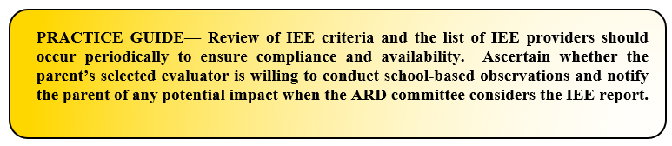
If a parent or guardian obtains a private evaluation and shares the results with the District, those results, if the private evaluation meets the District’s criteria, will be considered by the student’s ARD committee in any decision made with respect to the provision of a free appropriate public education to the student.
AUTISM
Students with autism typically have a developmental disability significantly impacting verbal and nonverbal communication and social interaction which adversely affects a student’s educational performance. This delay generally manifests prior to age 3.
A student may not be determined eligible as a student with autism if the student’s educational performance is adversely affected primarily because the student has an emotional disturbance.
The written evaluation report by the group of qualified professionals must include specific recommendations for behavioral interventions and strategies.
Additional characteristics associated with autism may include—
- engagement in repetitive activities and stereotyped movements;
- resistance to environmental change or change in daily routines; and/or
- unusual responses to sensory experiences.
A student who manifests the characteristics of autism after age 3 could be identified as having autism if the criteria in this section are identified.
The definitions of conditions or categories that are used for purposes of establishing an individual's eligibility for mental health services, as found in the Diagnostic and Statistical Manual of Mental Disorders (DSM), are not synonymous with criteria used for determining whether a child is a “child with a disability” for purposes of establishing eligibility for services under the IDEA. The group of qualified professionals conducting an evaluation of a student suspected of having autism will conduct assessments and observations, and collect data, as necessary for the ARD Committee to make an eligibility determination.
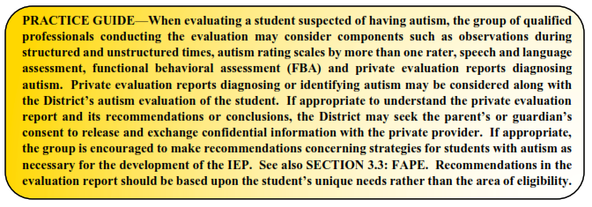
DEAF-BLINDNESS
A student who may be eligible under the category of deaf-blindness must have concurrent or coexistent hearing and visual impairments. Additionally, the combination of these impairments must cause such severe communication and other developmental and educational needs that the eligible student cannot be accommodated in a special education program solely for children with deafness or children with blindness.
A student with deaf-blindness is one who, based on an evaluation conducted in accordance with the procedures outlined in SECTION 2.0: EVALUATIONS, meets—
- the eligibility criteria for deaf or hard of hearing and visual impairment;
- the eligibility criteria for a student with a visual impairment and has a suspected hearing loss that cannot be demonstrated conclusively, but a speech/language therapist, a certified speech and language therapist, or a licensed speech language pathologist indicates there is no speech at an age when speech would normally be expected;
A student with deaf-blindness is also one who, based on an evaluation conducted in accordance with the procedures outlined in SECTION 2.0: EVALUATIONS, has—
- documented hearing and visual losses that, if considered individually, may not meet the requirements for deaf or hard of hearing or visual impairment, but the combination of such hearing and visual losses adversely affects the student's educational performance; or
- a documented medical diagnosis of a progressive medical condition that will result in concomitant hearing and visual losses that, without special education intervention, will adversely affect the student's educational performance.
The group of qualified professionals conducting an evaluation of a student suspected of having deaf-blindness will conduct assessments and observations, and collect data, as necessary for the ARD Committee to make an eligibility determination.

DEAF OR HARD OF HEARING
A student may be eligible for special education and related services as a student who is deaf or hard of hearing if the hearing impairment is so severe that it impairs the processing of linguistic information through hearing with or without amplification, and that adversely affects educational performance.
The group of qualified professionals must ensure that the evaluation data includes—
- An otological examination performed by an otolaryngologist or by a licensed medical doctor, with documentation that an otolaryngologist is not reasonably available, and an audiological evaluation performed by a licensed audiologist, and
- a description of the implications of the hearing loss for the student's hearing in a variety of circumstances with or without recommended amplification.
The group of qualified professionals conducting an evaluation of a student suspected of being deaf or hard of hearing will conduct assessments and observations, and collect data, as necessary for the ARD Committee to make an eligibility determination. The group should consider the student’s unique mode of communication when conducting the evaluation.
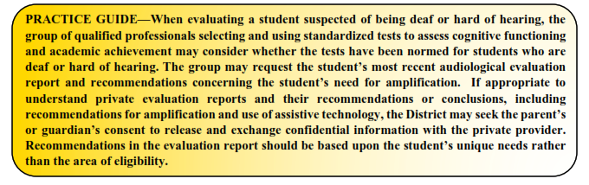

EMOTIONAL DISTURBANCE
A student may be eligible for special education and related services as a student with an emotional disturbance if the student exhibits one or more of the following characteristics over a long period of time and to a marked degree that adversely affects educational performance:
- an inability to learn, which cannot be explained by intellectual, sensory, or health factors;
- an inability to build or maintain satisfactory interpersonal relationships with peers and teachers;
- inappropriate types of behavior or feelings under normal circumstances;
- a general pervasive mood of unhappiness or depression; or
- a tendency to develop fears or physical symptoms associated with personal or school problems.
The term "emotional disturbance" also includes students with schizophrenia. The term does not include a student who is socially maladjusted unless the ARD Committee determines based on evaluation by a group of qualified professionals that the student has an emotional disturbance consistent with the criteria outlined above. The term “social maladjustment” is a persistent pattern of violating social norms with truancy, substance abuse, perpetual struggle with authority or manipulation.
With respect to the criterion that the student manifest one or more characteristics of emotional disturbance to a “marked degree,” this generally refers to the frequency, duration, or intensity of a student’s emotionally disturbed behavior in comparison to the behavior of peers and can be indicative of either degree or acuity or pervasiveness.
The definitions of conditions or categories that are used for purposes of establishing an individual's eligibility for mental health services, as found in the Diagnostic and Statistical Manual of Mental Disorders (DSM), are not synonymous with criteria used for determining whether a child is a “child with a disability” for purposes of establishing eligibility for services under the IDEA. IDEA neither requires nor precludes the application of the DSM criteria in making eligibility determinations. The DSM classification system may assist the group of qualified professionals in evaluating and diagnosing disability conditions in students, including the disability condition of emotional disturbance.
The group of qualified professionals conducting an evaluation of a student suspected of having an emotional disturbance will conduct assessments and observations, and collect data, as necessary for the ARD Committee to make an eligibility determination.
The group of qualified professionals must ensure that the written evaluation report includes specific recommendations for behavioral supports and interventions.

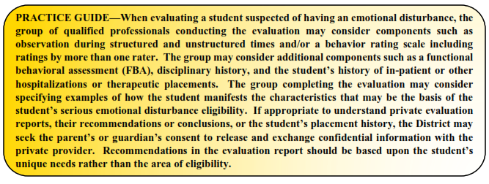

INTELLECTUAL DISABILITY
A student with an intellectual disability displays significantly sub-average general intellectual functioning, coexisting with deficits in adaptive behavior, that adversely affects the student’s educational performance. The student’s sub-average general intellectual functioning and coexistent deficits in adaptive behavior typically manifest during the student’s developmental period.
A student with an intellectual disability is one who:
- has been determined to have significantly sub-average intellectual functioning as measured by a standardized, individually administered test of cognitive ability in which the overall test score is at least two standard deviations below the mean, when taking into consideration the standard error of measurement of the test; and
- concurrently exhibits deficits in at least two of the following areas of adaptive behavior: communication, self-care, home living, social/interpersonal skills, use of community resources, self-direction, functional academic skills, work, leisure, health, or safety.
The group of qualified professionals conducting an evaluation of a student suspected of having an intellectual disability will conduct assessments and observations, and collect data, as necessary for the ARD Committee to make an eligibility determination.
It is permissible to have evaluation criteria that use intelligence tests to determine whether a child has a disability, provided that the intelligence test has been validated for the specific purpose for which it is being used, that neither the test itself nor its administration is racially or culturally discriminatory, and does not constitute the sole criterion for determining an appropriate educational program for a child.
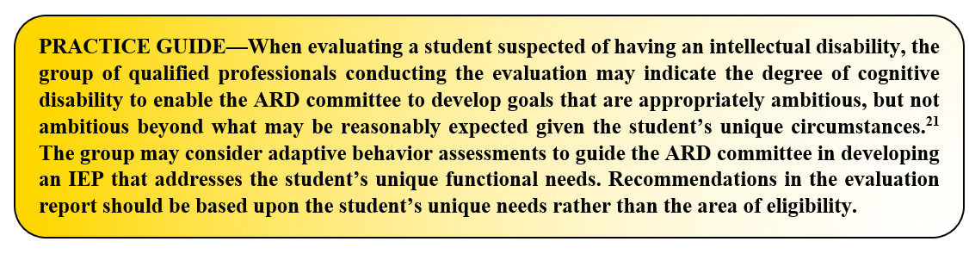

MULTIPLE DISABILITIES
A student who may be eligible for special education and related services as a student with multiple disabilities has more than one disability or concurrent impairments (such as intellectual disability and a visual impairment or an emotional disturbance and orthopedic impairment). The combination of these disabilities results in such severe educational need that the student cannot be accommodated in special education programs designed solely for students with one of the impairments. “Multiple disabilities” does not include deaf-blindness.
To qualify as a student with multiple disabilities, the student must have a combination of disabilities and meet all of the following conditions—
- The student's disability is expected to continue indefinitely, and
- the disabilities severely impair performance in two or more of the following areas:
  - psychomotor skills
  - self-care skills
  - communication
  - social and emotional development; or
  - cognition.
Students who have more than one of the disabilities but who do not meet the criteria cited above must not be classified or reported as having multiple disabilities.
The group of qualified professionals conducting an evaluation of a student suspected of having multiple disabilities will conduct assessments and observations, and collect data, as necessary for the ARD Committee to make an eligibility determination.

ORTHOPEDIC IMPAIRMENT

A student with a severe orthopedic impairment adversely affecting her or his educational performance may be eligible for special education and related services. The phrase orthopedic impairment includes impairments caused by disease, like poliomyelitis or bone tuberculosis, as well as impairments from other causes, such as cerebral palsy, amputations, and fractures or burns that cause contractures.
The group of qualified professionals that collects or reviews evaluation data in connection with the determination of a student's eligibility based on an orthopedic impairment must include a licensed physician. “Medical services” under IDEA are defined as services provided by a licensed physician to determine whether a child has a medically related disabling condition, which results in the child's need for special education and related services. The District will ensure that such services are at no cost to the parent.
The group of qualified professionals conducting an evaluation of a student suspected of having an orthopedic impairment will conduct assessments and observations, and collect data, as necessary for the ARD Committee to make an eligibility determination.
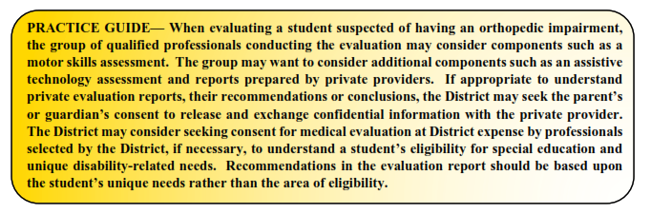

OTHER HEALTH IMPAIRMENT

A student may be eligible for special education and related services as a student with Other Health Impairment (OHI) if the student exhibits limited strength, vitality or alertness, including a heightened alertness to environmental stimuli, resulting in limited alertness in the educational environment, which is due to chronic or acute health problems, and by reason thereof demonstrates an educational need for specially designed instruction.
This disability category includes such health conditions as asthma, attention deficit disorder or attention deficit hyperactivity disorder, diabetes, epilepsy, a heart condition, hemophilia, lead poisoning, leukemia, nephritis, rheumatic fever, sickle cell anemia, and Tourette syndrome. The list of acute or chronic health conditions in the definition of OHI is not exhaustive, but rather provides examples of problems that children have that could make them eligible for special education and related services under the category of other health impairment.
The group of qualified professionals that collects or reviews evaluation data in connection with the determination of a student's eligibility based on other health impairment must include a licensed physician. “Medical services” under IDEA are defined as services provided by a licensed physician to determine whether a child has a medically related disabling condition, which results in the child's need for special education and related services. The District will ensure that such services are at no cost to the parent.
The group of qualified professionals conducting an evaluation of a student suspected of having an OHI will conduct assessments and observations, and collect data, as necessary for the ARD Committee to make an eligibility determination.
SPECIFIC LEARNING DISABILITY
See also SECTION 2.7: EVALUATIONS.
Prior to conducting an initial evaluation of a student suspected of having a specific learning disability, in order to ensure that underachievement in a student suspected of having a specific learning disability is not due to lack of appropriate instruction in reading or mathematics, the group of qualified professionals will consider the following:

- Data that demonstrates the student was provided appropriate instruction in reading and/or mathematics within general education settings delivered by qualified personnel.
- Data-based documentation of repeated assessments of achievement at reasonable intervals, reflecting formal evaluation of student progress during instruction, which must be provided to the student’s parents.
  - Documentation of the repeated assessments may include RtI progress monitoring data, in-class tests on grade-level curriculum, or other regularly administered District or classroom assessments. Intervals are considered reasonable if consistent with the assessment requirements of a student's specific instructional program.

In order to qualify as a student with a specific learning disability (SLD), the student—

- has been determined through a variety of assessment tools and strategies to meet the criteria for a specific learning disability;
- does not achieve adequately for the student's age or meet state-approved grade-level standards in oral expression, listening comprehension, written expression, basic reading skill, reading fluency skills, reading comprehension, mathematics calculation, or mathematics problem solving when provided learning experiences and instruction appropriate for the student’s age or state-approved grade-level standards, as indicated by performance on multiple measures such as in-class tests; grade average over time (e.g. six weeks, semester); norm- or criterion-referenced tests; and statewide assessments;
- does not make sufficient progress to meet age or state-approved grade-level standards in oral expression, listening comprehension, written expression, basic reading skill, reading fluency skills, reading comprehension, mathematics calculation, or mathematics problem solving when using a process based on the student's response to scientific, research-based intervention; or
- exhibits a pattern of strengths and weaknesses in performance, achievement, or both relative to age, state-approved grade-level standards, or intellectual development that is determined to be relevant to the identification of a specific learning disability, using appropriate assessments.
- Except that the student is not one with a specific learning disability if the findings specified above are primarily the result of: a visual, hearing, or motor disability; an intellectual disability; emotional disturbance; cultural factors; environmental or economic disadvantage; or emergent bilingual skills.

When considering a student for eligibility as a student with a specific learning disability, the student must be observed in the student’s learning environment, including the regular classroom setting, to document the student’s academic performance and behavior in the areas of difficulty.

The ARD Committee must decide to either:

- use information from an observation in routine classroom instruction and monitoring of the student's performance that was done before the student was referred for an evaluation; or
- have at least one member of the group of qualified professionals conduct an observation of the student's academic performance in the regular classroom after the student has been referred for an evaluation and the school has obtained parental consent.
The group of qualified professionals conducting an evaluation of a student suspected of having a specific learning disability will conduct assessments and observations, and collect data, as necessary for the ARD Committee to make an eligibility determination.

SPEECH OR LANGUAGE IMPAIRMENT
A speech or language impairment includes communication disorders, such as stuttering, impaired articulation, expressive or receptive language impairment, or voice impairment that adversely affects a student’s educational performance.
The group of qualified professionals that collects or reviews evaluation data in connection with the determination of a student's eligibility based on a speech or language impairment must include a certified speech and hearing therapist, a certified speech and language therapist, or a licensed speech/language pathologist.
The group of qualified professionals conducting an evaluation of a student suspected of having a speech or language impairment will conduct assessments and observations, and collect data, as necessary for the ARD Committee to make an eligibility determination.
TRAUMATIC BRAIN INJURY
Students with traumatic brain injury have acquired injury to the brain caused by an external physical force, resulting in total or partial functional disability or psychosocial impairment, or both, that adversely affects educational performance. The term applies to open or closed head injuries resulting in impairments in one or more areas, such as cognition; language; memory; attention; reasoning; abstract thinking; judgment; problem-solving; sensory, perceptual, and motor abilities; psychosocial behavior; physical functions; information processing; and speech. The term does not apply to injuries that are congenital or degenerative, or to brain injuries induced by birth trauma.
The group of qualified professionals that collects or reviews evaluation data in connection with the determination of a student's eligibility based on a traumatic brain injury must include a licensed physician, in addition to—
- a licensed specialist in school psychology (LSSP)
- an educational diagnostician, or
- other appropriately certified or licensed practitioner with experience and training in the area of the disability.
“Medical services” under IDEA are defined as services provided by a licensed physician to determine whether a child has a medically related disabling condition, which results in the child's need for special education and related services. The District will ensure that such services are at no cost to the parent.
The group of qualified professionals conducting an evaluation of a student suspected of having a traumatic brain injury will conduct assessments and observations, and collect data, as necessary for the ARD Committee to make an eligibility determination.
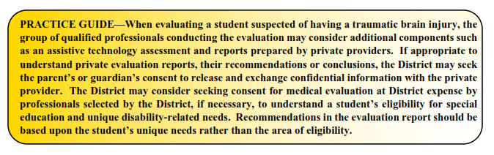
VISUAL IMPAIRMENT
A student with a visual impairment may qualify for special education and related services if the student has an impairment in vision, even with correction (such as glasses or contact lenses), that adversely affects educational performance. The phrase visual impairment includes both partial sight and blindness. Information from a variety of sources must be considered by the group of qualified professionals that collects or reviews evaluation data in connection with the determination of the student’s eligibility based on visual impairment in order to determine the need for specially designed instruction.

A student with a visual impairment is one who—
- has been determined by a licensed ophthalmologist or optometrist to
  - have no vision or to have a serious visual loss after correction or
  - have a progressive medical condition that will result in no vision or a serious visual loss after correction.
The group of qualified professionals that collects or reviews evaluation data in connection with the determination of a student's eligibility based on a visual impairment includes a person who is appropriately certified as an orientation and mobility specialist. The District must ensure that an appropriately certified orientation and mobility specialist is included in any reevaluation of a student who has been determined to be eligible for the district's special education program on the basis of a visual impairment.
The written report from the group of qualified professionals includes:
- a medical report by a licensed ophthalmologist or optometrist that indicates the student’s visual loss stated in exact measures of visual field and corrected visual acuity, at a distance and at near range, in each eye. If exact measures cannot be obtained, the eye specialist must so state and provide best estimates. The report by the licensed ophthalmologist or optometrist should also include prognosis whenever possible and whether the student has no vision or visual loss after correction; or a progressive medical condition that will result in no vision or a visual loss after correction;
- a functional vision evaluation by a certified teacher of students with visual impairments or a certified orientation and mobility specialist that includes the performance of tasks in a variety of environments requiring the use of both near and distance vision and recommendations concerning the need for a clinical low vision evaluation;
- a learning media assessment by a certified teacher of students with visual impairments including recommendations concerning which specific visual, tactual, and/or auditory learning media are appropriate for the student and whether or not there is a need for ongoing evaluation in this area; and
- an orientation and mobility evaluation conducted by a person who is appropriately certified as an orientation and mobility specialist and must be conducted in a variety of lighting conditions and in a variety of settings, including in the student's home, school, and community and in settings unfamiliar to the student.
The group of qualified professionals conducting an evaluation of a student suspected of having a visual impairment will conduct assessments and observations, and collect data, as necessary for the ARD Committee to make an eligibility determination.

NON-CATEGORICAL EARLY CHILDHOOD

Children between the ages of 3-5 who are evaluated as having an intellectual disability, an emotional disturbance, a specific learning disability or autism may be described as “non-categorical early childhood” for the purposes of special education eligibility.

The group of qualified professionals that collects or reviews evaluation data in connection with the determination of the child's eligibility based on non-categorical early childhood must include the applicable members for intellectual disability, emotional disturbance, specific learning disability, or autism. The group of qualified professionals conducting an evaluation of a student suspected of meeting eligibility criteria for a non-categorical early childhood disability will conduct assessments and observations, and collect data, as necessary for the ARD Committee to make an eligibility determination.

FOR MORE INFORMATION ABOUT EACH AREA OF ELIGIBILITY

In Texas, eligibility is determined by the student’s Admission, Review and Dismissal (ARD) committee. The phrase multidisciplinary team refers to the group of District staff tasked with using a variety of assessment tools and strategies to gather relevant functional, academic and developmental information about the student, including information provided by the parent, as part of the special education evaluation process.
- For more information about AUTISM, please contact Big 4.

- For more information about DEAF-BLINDNESS, please contact Big 4.

- For more information about DEAF OR HARD OF HEARING, please contact Big 4.

- For more information about EMOTIONAL DISTURBANCE, please contact Big 4.

- For more information about INTELLECTUAL DISABILITY, please contact Big 4.

- For more information about MULTIPLE DISABILITIES, please contact Big 4

- For more information about ORTHOPEDIC IMPAIRMENT, please contact Big 4.

- For more information about OTHER HEALTH IMPAIRMENT, please contact Big 4.

- For more information about SPECIFIC LEARNING DISABILITY, please contact Big 4.

- For more information about SPEECH OR LANGUAGE IMPAIRMENT, please contact Big 4.

- For more information about TRAUMATIC BRAIN INJURY, please contact Big 4.

- For more information about VISUAL IMPAIRMENT, please contact Big 4.

- For more information about NON-CATEGORICAL EARLY CHILDHOOD, please contact Big 4.

William V. v. Copperas Cove, 77 IDELR 92 (5th Cir., September 14, 2020) (the 5th Circuit applies this two part test—the combination of a qualifying disability and educational need)
34 C.F.R. § 300.301(c)(2)
Tex. Ed. Code § 26.002
34 C.F.R. § 300.30(a)
71 Fed. Reg. 46,568(2006); 34 C.F.R. § 300.30 (b)(1)(“If a judicial decree or order identifies a specific person or persons . . . to act as the ‘parent’ of a student or to make educational decisions on behalf of a student, then such person or persons shall be determined to be the ‘parent’ for purposes of this section”).
Tex. Ed. Code § 29.015(a); 19 TEX. ADMIN. CODE § 89.1047
Tex. Ed. Code § 29.015(b)
19 TEX. ADMIN. CODE § 89.1049(a)
Tex. Ed. Code § 29.0151(b)
Tex. Ed. Code § 29.0151(c)
Tex. Ed. Code § 29.0151(d)
Tex. Ed. Code § 25.007
34 C.F.R. § 300.503
Tex. Ed. Code § 29.0041
19 TEX. ADMIN. CODE § 89.1011(c)
Id.
19 TEX. ADMIN. CODE § 89.1011(c)(1)
19 TEX. ADMIN. CODE § 89.1011(h)
19 TEX. ADMIN. CODE § 89.1011(e)
Id.
19 TEX. ADMIN. CODE § 89.1011(f)
Id.
34 CFR § 300.101
Tex. Ed. Code § 29.0041
Shelby S v Conroe ISD, 454 F3d 450 (5th Cir. 2006); Andress v. Cleveland ISD, 64 F.3d 176 (5th Cir. 1995)
34 C.F.R. § 300.507
34 C.F.R. § 300.304(b)
34 C.F.R. § 300.304(c)(3)
34 C.F.R. § 300.304(c)(4)
34 C.F.R. § 300.304(c)(6)
34 C.F.R. § 300.304(c)
19 TEX. ADMIN. CODE § 89.1040(c)(9)(C)
19 TEX. ADMIN. CODE § 89.1040(c)(9)(B); 34 C.F.R. § 300.309
19 TEX. ADMIN. CODE § 89.1040(c)(9)(B)
Id.
Id.
19 TEX. ADMIN. CODE § 89.1040(c)(9)(D); 34 CFR § 300.310(b)
19 TEX. ADMIN. CODE § 89.1040(c)(9)(E)
D.L. v. Clear Creek Independent School District, 695 F. App’x 733 (5th Cir. 2017) (“[W]e consider whether there was a present need for special education services . . . [a] fear that a student may experience problems in the future is not by itself a valid basis for IDEA eligibility”(emphasis added).
34 C.F.R. § 300.39(a)(1)
34 C.F.R. § 300.39(b)(3)(emphasis added)
The educational standards applicable to all students in the state of Texas are also outlined in Tex. Ed. Code § 28.002 and in 19 TEX. ADMIN. CODE § 74.1.
34 C.F.R. § 300.306(b)
19 TEX. ADMIN. CODE § 89.1011(d); 34 C.F.R. § 300.306
34 C.F.R. § 300.305(a)
34 C.F.R. § 300.305(b)
34 C.F.R. § 300.305
34 C.F.R. § 300.300(d); 34 C.F.R. § 300.302
34 C.F.R § 300.303(a)
34 C.F.R. § 300.303(b)
34 C.F.R. § 300.300(c)
34 C.F.R. § 300.303(b)(2)
OSEP. Part B Implementation of IDEA Provision of Services in the Current COVID-19 Environment Q&A Document. September 28, 2020.
34 C.F.R. § 300.305(e)(1)
19 TEX. ADMIN. CODE § 89.1070(g); 34 C.F.R. § 300.305(e)(2)
19 TEX. ADMIN. CODE § 89.1070(g); 34 C.F.R. § 300.305(e)(3)
34 C.F.R. § 300.502
34 C.F.R. § 300.502(a)(3)(i) – (b)(2)
34 C.F.R. § 300.502(b)(4)
34 C.F.R. § 300.502(c)
34 C.F.R. § 300.8(c)(1)
34 C.F.R. § 300.8(c)(1)(ii)
19 TEX. ADMIN. CODE §89.1040(c)(1)
34 C.F.R. § 300.8(c)(1)(iii)
Letter to Coe (OSEP 9/14/1999)
34 C.F.R. § 300.8(c)(2)
19 TEX. ADMIN. CODE §89.1040(c)(2)
The terms deaf or hard of hearing are referenced in Texas law while federal law typically references the terms deafness and hearing impairment.
34 C.F.R. § 300.8(c)(3)
19 TEX. ADMIN. CODE §89.1040(c)(3)
Tex. Ed. Code § 29.303
34 C.F.R. § 300.8(c)(4)
Hansen v. Republic R-III School District, 632 F.3d 1024 (8th Cir. 2011); Springer v. Fairfax County School Board, 134 F.3d 659 (4th Cir. 1998).
Letter to Anonymous (OSEP 8/11/1989)
Letter to Coe (OSEP 9/14/1999)
Letter to Woodson (OSEP 4/5/1989)
19 TEX. ADMIN. CODE §89.1040(c)(4)
34 C.F.R. § 300.8(c)(6)
19 TEX. ADMIN. CODE §89.1040(c)(5)
Letter to Warrington (OSEP 9/2/1993)
E.R. v. Spring Branch Independent School District, 909 F.3d 754 (5th Cir. 2018)
34 C.F.R. § 300.8(c)(7)
19 TEX. ADMIN. CODE §89.1040(c)(6)
34 C.F.R. § 300.8(c)(8)
19 TEX. ADMIN. CODE §89.1040(c)(7)
34 C.F.R. § 300.34(c)(5)
Letter to Anonymous (OSEP 6/3/2020)
34 C.F.R. § 300.8(c)(9)
Id.
71 Fed. Reg. 46550 (August 14, 2006)
Letter to Sterner (OSEP 8/19/1998)
19 TEX. ADMIN. CODE §89.1040(c)(8)
34 C.F.R. § 300.34(c)(5)
Letter to Anonymous (OSEP 6/3/2020)
Alvin Independent School District v. A.D., 503 F.3d 378 (5th Cir. 2007)(Student was not eligible under IDEA because he had passing grades and success on state skills test evidencing academic progress; his teachers testified that, despite his behavioral issues, he did not need special education and was achieving social success in school; many of his behavioral problems resulted from non-ADHD related issues like alcohol abuse and a death in the family).
19 TEX. ADMIN. CODE § 89.1040(c)(9)
Id.; 34 C.F.R. § 300.309
34 C.F.R. § 300.310(b)
34 C.F.R. § 300.310(c)(11)
19 TEX. ADMIN. CODE § 89.1040(c)(10)
34 C.F.R. § 300.8(c)(12)
22 TEX. ADMIN. CODE § 465.38(b)(1)
19 TEX. ADMIN. CODE § 89.1040(c)(11)
34 C.F.R. § 300.34(c)(5)
Letter to Anonymous (OSEP 6/3/2020)
34 C.F.R. § 300.8(c)(13)
19 TEX. ADMIN. CODE § 89.1040(c)(12)(A)
19 TEX. ADMIN. CODE § 89.1040(c)(12)(C)
19 TEX. ADMIN. CODE § 89.1040(c)(12)(B)
19 TEX. ADMIN. CODE § 89.1040(c)(12)(A)(i)
19 TEX. ADMIN. CODE § 89.1040(c)(12)(A)(ii)
19 TEX. ADMIN. CODE § 89.1040(c)(12)(A)(iii)
19 TEX. ADMIN. CODE § 89.1040(c)(12)(A)(iv)
19 TEX. ADMIN. CODE § 89.1040(c)(13)
19 TEX. ADMIN. CODE § 89.1040(b); 19 TEX. ADMIN. CODE § 89.1050(a)(5)
34 C.F.R. § 300.306

