THROCKMORTON INDEPENDENT SCHOOL DISTRICT
SPECIAL EDUCATION OPERATING PROCEDURES

THROCKMORTON ISD has entered into an Interlocal Agreement to cooperatively operate its special education programs under the authority of Tex. Ed. Code § 11.157. The Big 4 Shared Services Arrangement may provide for the efficient delivery of legally required special education and related services to the THROCKMORTON ISD’s eligible students with disabilities as set forth in the Interlocal Agreement, including the implementation of these Special Education Operating Procedures.

3.0 FREE APPROPRIATE PUBLIC EDUCATION (FAPE)

3.1 What is a free appropriate public education (FAPE)?
3.2 How is a student’s IEP developed?
3.3 How does the District develop an IEP for a newly enrolled student who had an IEP prepared by another public school?
3.4 What is in a student’s IEP?
3.5 How does the District use Prior Written Notice (PWN) to keep parents informed about the decisions of a student’s ARD committee?
3.6 How does a student’s ARD committee make a placement decision?
3.7 How does the District respond to a parent’s request for private placement when there is a disagreement regarding FAPE?
3.8 What happens if an ARD committee meeting ends in disagreement?
3.9 When and how is a student’s IEP updated?
3.10 How does the District ensure parents are included in the IEP development process?
3.11 How does the District ensure that parents with emergent bilingual abilities are included in the IEP development process?
3.12 How does the District ensure that a student’s IEP is implemented?
3.13 How does the District determine compensatory services for students whose FIIE was delayed or whose IEP was interrupted, reduced, delayed, suspended, or discontinued during the 2019-2020 or 2020-2021 school years?
3.14 How does the District ensure adult students are included in the IEP development process?
3.15 What happens when a student with an IEP graduates with a regular high school diploma?
3.16 What are the District’s obligations to children transitioning from IDEA Part C Early Intervention Services (EIS) to IDEA Part B Early Childhood Special Education (ECSE)?
3.17 Are there limitations on the right to FAPE?
3.18 How does the District provide FAPE via virtual or remote instruction?

THROCKMORTON ISD Board Policy along with these Special Education Operating Procedures constitute the Policies and Procedures of THROCKMORTON ISD which are designed to be consistent with the State policies and procedures developed pursuant to the IDEA. THROCKMORTON ISD Special Education Operating Procedures are not for the purpose of creating a requirement that is not otherwise imposed by the Individuals with Disabilities Education Improvement Act (“IDEA”), together with its implementing federal regulations, state statutes and rules, as they shall from time to time be amended, and shall not be construed to create a higher standard than that established by IDEA. These Special Education Operating Procedures are adopted by the Office of the Superintendent and shall be posted on THROCKMORTON ISD’s website. These Special Education Operating Procedures must be interpreted consistent with the IDEA. THROCKMORTON ISD’s Special Education Operating Procedures are reviewed and updated, as needed, on at least an annual basis. THROCKMORTON ISD will make timely changes to policies and procedures in response to IDEA amendments, regulatory or rule changes, changes to state policy, or new legal interpretation as are necessary to bring THROCKMORTON ISD into compliance with the requirements of IDEA. THROCKMORTON ISD maintains systems to ensure that all students with disabilities residing in the District, including students with disabilities attending non-public schools, regardless of the severity of their disabilities, and who are in need of special education and related services, are identified, located, and evaluated and provided a free appropriate public education. THROCKMORTON ISD maintains systems designed to ensure that students with disabilities and their parents or guardians are afforded the procedural safeguards required under the IDEA (and its implementing federal regulations, state statutes and rules), including with respect to the confidentiality of records and personally identifiable information.

3.0 FREE APPROPRIATE PUBLIC EDUCATION

3.1 What is a free appropriate public education (FAPE)?

Every eligible THROCKMORTON ISD student with a disability is entitled to a free appropriate public education. Each student’s Individualized Education Program (IEP) is the centerpiece of the District’s plan for providing appropriate special education and related services that are reasonably calculated to enable the student to make progress appropriate in light of the student’s unique and individual circumstances.

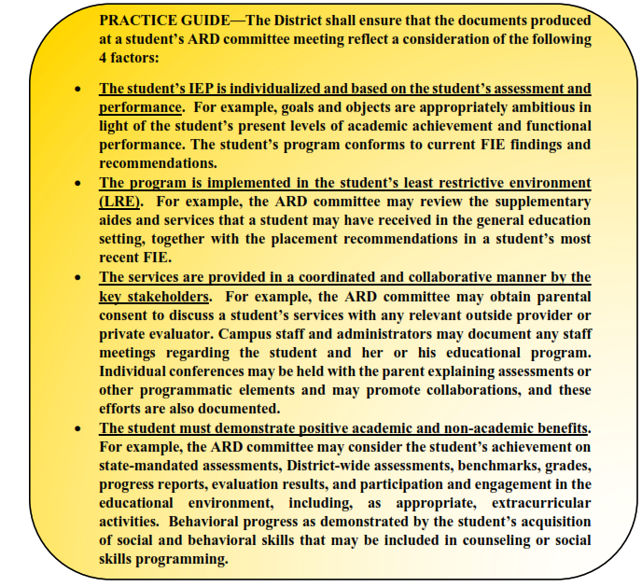
3.2 How is a student’s IEP developed?

For each eligible student with a disability, the Big 4 SSA shall establish an ARD committee. Each student’s ARD committee shall include the following participants:

- a parent or adult student;

- a general education teacher of the student if the student is or may be participating in the general education environment. The student’s general education teacher, shall, to the extent appropriate, participate in the development of the student’s IEP, including the determination of appropriate positive behavioral interventions and supports and other strategies for the child, supplementary aids and services, program modifications, and support for school personnel;

- a special education teacher of the student. The special education teacher or provider who is a member of the student’s ARD committee should be the person who is responsible for implementing the IEP. For example, if the student’s disability is a speech impairment, the special education teacher or special education provider could be the speech language pathologist;

- a representative of the District who is qualified to provide, or supervise the provision of, specially designed instruction and is knowledgeable about the general education curriculum and about the availability of District resources. The District’s representative may be the Director of Special Education or campus designee or a campus administrator acting on behalf of the District. The choice of the representative is at the discretion of the District, so long as the District’s representative meets these criteria;

- an individual who can interpret the instructional implications of evaluation results, such as a Licensed Specialist in School Psychology (LSSP) or an Educational Diagnostician;

- at the discretion of the parent, guardian or the District, other individuals who have knowledge or special expertise regarding the student, including related services personnel as appropriate; and

- whenever appropriate, the student.

The ARD committee shall also include the following additional participants, as appropriate:

- with the consent of a parent, guardian or a student who has reached the age of majority, a representative of any participating agency likely to be responsible for providing or paying for transition services. The Big 4 SSA case manager, to the extent practicable under the circumstances, shall document efforts to obtain parental consent for the participation of an individual from outside agencies, prior to or at the beginning of a student’s ARD committee meeting wherein transition services will be discussed;

- a representative from the District’s Career and Technical Education (CTE) when the student’s ARD committee is considering placement of a student in CTE;

- if the student is identified as an emergent bilingual student, a professional staff member who is on the District’s Language Proficiency Assessment Committee in accordance with THROCKMORTON ISD’s Policy EHBE(Legal);

- if the student is a student with a suspected or documented visual impairment, a teacher who is certified in the education of students with visual impairments;

- if the student is a student who is suspected to be or is documented to be deaf or hard of hearing the student’s Teacher of the Deaf and Hard of Hearing; and

- if the student is a student with suspected or documented deaf-blindness, a teacher who is certified in the education of students with visual impairments and a teacher who is certified in the education of students who are deaf or hard of hearing.

Required members must be present for the ARD committee meeting unless properly excused by the parent or guardian and the District. IDEA requires different procedures for different types of excusals, including differentiating between circumstances in which parental consent is required and when an agreement is required to excuse a mandatory ARD committee member from attending an ARD committee meeting. Therefore, THROCKMORTON ISD has different procedures in place for the different types of excusals. The two types of excusals triggering the excusal requirements are: (1) when a required ARD committee member’s area of the curriculum or expertise is not being modified or discussed; and (2) when a required ARD committee member’s area of the curriculum or expertise is being modified or discussed.

With the first type of excusal, parent or guardian and THROCKMORTON ISD agreement is required; however, THROCKMORTON ISD is given wide latitude about the content of the agreement to excuse a required ARD committee member from the meeting. With the second type of excusal, parent or guardian consent is also required, and the member must submit in writing, to the parent or guardian and the ARD committee, input into the development of the IEP prior to the meeting. When consent is required, Big 4 SSA case manager will ensure that all of the IDEA consent requirements are satisfied, including by providing the parent or guardian with appropriate and sufficient information to ensure that the parent or guardian fully understands that the parent or guardian is consenting to excuse an ARD committee member from attending an ARD meeting in which the member’s area of the curriculum or expertise is being changed or discussed. The parent or guardian must also be informed that if the parent does not consent, the ARD committee meeting must be held with that ARD committee member in attendance. The Big 4 SSA case manager shall document all ARD committee meeting participants, including any member who is excused prior to or during the meeting, and shall verify that the excusal procedures have been followed.

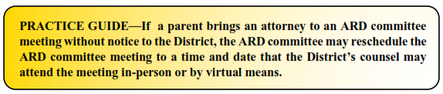
Within 30 calendar days from the date of the completion of the student’s initial special education evaluation report, the student’s ARD committee shall make its decisions regarding the student’s initial eligibility, and, if appropriate, her or his individualized education program (IEP) and placement.

At a duly constituted ARD committee meeting that is conducted after at least 5 school days-notice to the student’s parent or guardian, the student’s ARD committee, including the student’s parent or guardian, shall develop an IEP, consistent with FAPE: Section 3.3 below, by considering—

- the student’s strengths; the concerns of the parents or guardians for enhancing the education of the student; the results of the student’s initial or most recent evaluation; and the present academic, developmental, and functional needs of the student;

- in the case of a student whose behavior impedes the student’s learning or that of others, the use of positive behavioral interventions and supports, and other strategies to address that behavior;

- the language needs of a student with emergent bilingual abilities as those needs relate to the student’s IEP;

- providing for instruction in Braille and the use of Braille unless the ARD committee determines, after an evaluation of the student’s reading and writing skills, needs, and appropriate reading and writing media (including an evaluation of the student’s future needs for instruction in Braille or the use of Braille), consistent with EVALUATIONS: Section 2.0 above, that instruction in Braille or the use of Braille is not appropriate for the student;

- the communication needs of the student, including, for a student who is deaf or hard of hearing, the student’s opportunities for direct communications with peers and professional personnel in the child's language and communication mode, academic level, and full range of needs, including opportunities for direct instruction in the student’s language and communication mode; and

- the student’s need for assistive technology devices and services.

3.3 How does the District develop an IEP for a newly enrolled student who had an IEP from another public school?

- Students who enroll during the summer. When a student with a disability has an IEP in place from a previous in- or out-of-state school district and enrolls in THROCKMORTON ISD during the summer, THROCKMORTON ISD implements the IEP from the previous public school district in full on the first day of class of the new school year or must convene an ARD committee meeting during the summer to revise the student's IEP for implementation on the first day of class of the new school year.

- Students who enroll during the school year with an IEP in effect from another public school in Texas. When a student transfers to THROCKMORTON ISD from another public school in Texas, in the same school year and the parents verify that the student was receiving special education services in the previous school district or the previous school district verifies in writing or by telephone that the student was receiving special education services, SPED teacher or campus designee will consult with the student’s parents to provide FAPE, including services comparable to those described in the child’s IEP from the previous public school. No later than 30 school days from the date the student is verified as being a student eligible for special education services Big 4 SSA Case Manager shall ensure that the ARD committee is convened to adopt the IEP from the previous public school or develops, adopts and implements a new IEP consistent with What is in a student’s IEP? Section 3.4, below.

- Students who enroll during the school year with an IEP in effect from another public school outside of Texas. When a student transfers to THROCKMORTON ISD from a public school district in a state other than Texas, in the same school year and the parents verify that the student was receiving special education services in the previous school district or the previous school district verifies in writing or by telephone that the student was receiving special education services, SPED teacher or campus designee will consult with the student’s parents to provide FAPE, including services comparable to those described in the child’s IEP from the previous public school.

Big 4 SSA will determine whether an evaluation is necessary consistent with
CHILD FIND: Section 1.0 and EVALUATIONS: Section 2.0. If Big 4 SSA determines that an evaluation is not necessary, Big 4 SSA will ensure that an ARD committee is convened to develop, adopt and implement a new IEP within 30 school days from the date the student is verified as being a student eligible for special education services. If an evaluation is determined necessary, it is considered a full individual and initial evaluation and must be completed consistent with EVALUATIONS: Section 2.0 above. Big 4 SSA will ensure that an ARD committee is convened to develop, adopt and implement a new IEP within 30 calendar days from the date of the completion of the evaluation report.

3.4 What is in a student’s IEP?

- Parent and Student Concerns. The Big 4 SSA shall ensure that the ARD committee elicits, considers and documents the concerns of the parent or guardian for enhancing the education of her or his child. This may be reflected in a concise statement summarizing the educational, social, behavioral and/or emotional concerns of the parent or guardian and student, as appropriate.

- Student Strengths and Relevant Evaluation Results. The Big 4 SSA shall ensure that the student’s IEP identifies the assessment data considered by the ARD committee, including both state and District-wide assessment results, as well as relevant information from any campus. Privately obtained assessments provided by the student’s parent or guardian shall be considered in any decision made with respect to the provision of FAPE to the student if it meets District criteria. To the extent appropriate, the student’s general education performance shall also be documented. This summary shall also include an explanation of how the student’s disability or disabilities impact the student’s progress and participation in the general education curriculum.

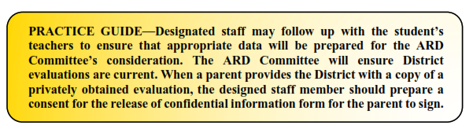

- Present Levels of Academic Achievement and Functional Performance (PLAAFP). The Big 4 SSA case manager shall coordinate with the student’s relevant ARD committee members, general and special education teachers, and/or related service providers, to ensure, through their preparation and participation in the ARD committee meeting and through the participation of the parent or guardian, that the student’s IEP contains an accurate description of how the student is performing in the areas of educational and functional need. The statement of present levels in a student’s IEP should convey sufficient information to provide clear levels of the student’s current academic and functional performance.

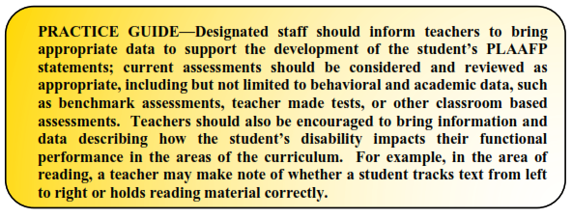

- Measurable Annual Goals. The Big 4 SSA case manager shall ensure that a student’s IEP, as developed by the ARD committee includes:
  - a statement of measurable annual goals, including academic and functional goals.

  - goals designed to meet the student’s needs that result from the student’s disability to enable the student to be involved and make progress in the general education curriculum, and to meet each of the student’s other educational needs that result from the student’s disability.

  - for students who take alternate assessments aligned to alternate achievement standards, a description of benchmarks and short term objectives.

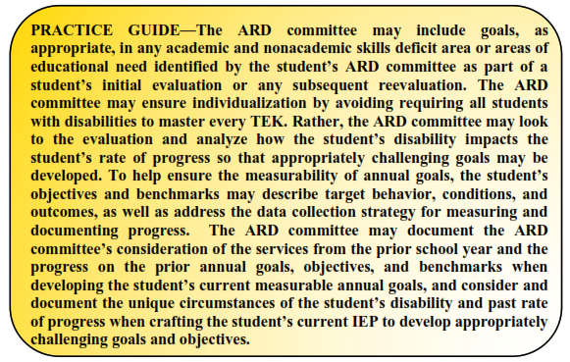

- Supplementary Aids and Services. The Big 4 SSA case manager shall ensure that the student’s IEP, as developed by the ARD committee, includes a statement of needed supplementary aids and services (aids, services, and other supports) in regular education classes, other education-related settings, and in extracurricular and nonacademic settings, to enable the student to be educated with non-disabled students to the maximum extent appropriate.

As part of supplementary aids and services, the IEP may include a list or a chart of all accommodations, behavioral or academic, determined by the student’s ARD committee to be appropriate to meet the educational needs of the student in the general education setting.

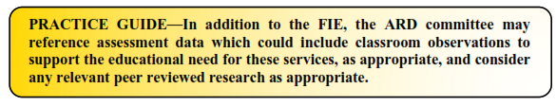

- Behavioral Supports and Interventions. In the case of a student with a disability whose behavior impedes the student’s own learning or that of others, the Big 4 SSA case manager shall ensure that the student’s ARD committee considers the use of positive behavioral interventions and supports, and other strategies, to address that behavior, and includes as part of the IEP any needed interventions, supports and strategies. The student’s ARD committee may determine that a behavior improvement plan or a behavioral intervention plan (BIP) is appropriate for a student. In such instances, the ARD committee determines the appropriate components of a BIP for the student’s individual needs; there are no formal requirements for a BIP. If the student’s ARD committee determines that a BIP is appropriate, the BIP shall be included as part of the student’s IEP and provided to each responsible teacher. If a BIP is included as part of a student’s IEP the Big 4 SSA case manager shall ensure that the ARD committee reviews the BIP at least annually and more frequently if appropriate to address the safety of the student or others, or changes in the student’s circumstances that may impact the student’s behavior. Circumstances that may impact the student’s behavior may include but are not limited to: a change of placement to a different educational setting; an increase or persistence in disciplinary actions for similar types of behavior; a pattern of unexcused absences; or unauthorized unsupervised departure from an educational setting. Students will be subject to the Student Code of Conduct (SCOC) consistent with students without disabilities, provided that any discipline under the SCOC shall be subject to the timelines and protections provided to a student with a disability under the IDEA, including holding an ARD Committee (MDR) meeting in connection with any “disciplinary change of placement” in accordance with the District’s FOF(Legal) policy.

- Specially Designed Instruction. The Big 4 SSA case manager shall ensure that the student’s IEP as developed by the ARD committee includes a statement of needed special education services. Special education means “specially designed instruction, at no cost to the parents, to meet the unique needs of a child with a disability.” Specially designed instruction means—

  - “adapting, as appropriate to the needs of an eligible child under this part, the content, methodology, or delivery of instruction-

      - To address the unique needs of the child that result from the child's disability; and
      - To ensure access of the child to the general curriculum, so that the child can meet the educational standards within the jurisdiction of the public agency that apply to all children.”

The general curriculum and educational standards that “apply to all children” in THROCKMORTON ISD are the Texas Essential Knowledge and Skills (TEKS) as well as the District’s Policy EIE(Local). The state-wide assessments that determine a student’s progress toward meeting those educational standards are the State of Texas Assessments of Academic Readiness (STAAR).

When developing specifically designed instruction, the student’s ARD committee shall consider—

  - How content, methodology and delivery of instruction will be modified from the general curriculum.

  - Student performance criteria that accurately and appropriately evidences the modification of the content of the performance or assessment.

- Program Modifications and Supports for School Personnel. The Big 4 SSA case manager shall ensure that the student’s IEP as developed by the ARD committee includes a statement of any needed program modifications or supports for campus and other District personnel that will be provided to enable the student: to advance appropriately toward attaining the annual goals in the student’s IEP; to be involved in and make progress in the general education curriculum; to participate in extracurricular and other nonacademic activities; and to be educated and participate with other students with disabilities and non-disabled students.

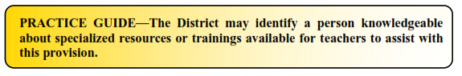

- Related Services. The Big 4 SSA case manager shall ensure that the student’s IEP as developed by the ARD committee includes any needed related services and the projected date for the beginning of the student’s related services, together with the anticipated frequency, location and duration of the student’s related services. Related services means transportation and such developmental, corrective, and other supportive services as are required to assist a student with a disability to benefit from special education, and includes: speech-language pathology and audiology services; interpreting services; psychological services; physical and occupational therapy; recreation, including therapeutic recreation; early identification and assessment of disabilities in children; counseling services, including rehabilitation counseling; orientation and mobility services; and medical services for diagnostic or evaluation purposes. Related services also include school health services and school nurse services, social work services in schools, and parent counseling and training. The Big 4 SSA case manager shall further ensure that the IEP developed by the ARD committee includes sufficient information about the amount and type of services, so that it is clear to the parent, as well as to the student’s related service providers and teachers, what level of support the student is to receive.

- Consideration of Strategies for Students with Autism. The Big 4 SSA case manager will ensure that for a student eligible for special education and related services as a student with Autism, the student’s ARD committee considers the eleven strategies as described in the District’s Autism Supplement, and includes as part of the IEP any strategies deemed necessary and appropriate for the student. Those strategies deemed necessary and appropriate for the student may be incorporated throughout the IEP and/or described in a supplement.
- Transition Services. Beginning not later than the first IEP to be in effect when a student turns 14 and then updated annually, the Big 4 SSA case manager shall ensure that the student’s IEP as developed by the student’s ARD committee includes:
- appropriate measurable postsecondary goals based upon age-appropriate transition assessments related to training, education, employment, and, where appropriate, independent living skills; and
- the transition services (including courses of study) needed to assist the student in reaching those goals.
The Big 4 SSA case manager shall further ensure that the student’s ARD committee complies with THROCKMORTON ISD’s Policy EHBAD(Legal) (“Special Education Transition Services”) regarding the procedures for including representatives from the Texas Workforce Commission on a student’s ARD committee.

- State and District-wide Assessment. The Big 4 SSA case manager shall ensure that the student’s IEP as developed by the ARD committee includes a statement of any individual appropriate accommodations that are necessary to measure the academic achievement and functional performance of the student on State and District-wide assessments. The ARD Committee will follow TEA guidelines when determining how a student will participate in the Texas Statewide Assessment Program, including how to select allowable accommodations, and in deciding whether a student with a disability meets the criteria to be assessed based on modified or alternate academic achievement standards. If the ARD committee determines that the student must take an alternate assessment instead of a particular regular State or district wide assessment of student achievement, Big 4 SSA case manager shall ensure as appropriate that the student’s IEP as developed by the ARD committee includes a statement of why the student cannot participate in the regular assessment and why the particular alternate assessment selected is appropriate for the student.

- Placement in the Least Restrictive Environment and the Justification for any Removal from General Education. Please see: FAPE: Section 3.5.

- Extended School Year (ESY) Services. Whenever appropriate, the student’s ARD committee shall determine whether the student requires an extended school year based on a regression-recoupment analysis. The need for ESY services shall be documented from formal and/or informal evaluations provided by the District or the student’s parents or guardians. The documentation must demonstrate that in one or more critical areas addressed in the student’s current IEP goals and objectives, the student has exhibited, or reasonably may be expected to exhibit, severe or substantial regression that cannot be recouped within a reasonable period of time. Severe or substantial regression means that the student has been, or will be, unable to maintain one or more acquired critical skills in the absence of ESY services. It is important to remember that ARD committee determinations regarding ESY services are prospective in nature and not intended to make up for past denials of FAPE, if any.

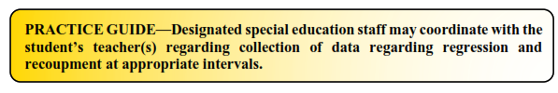
- Response to Bullying or Harassment. Following an investigation of a student with a disability who is an alleged victim or perpetrator of bullying or harassment in violation of the District’s FFH(Local) and FFI(Local) policies, an ARD committee meeting shall be held to review the conduct and to consider the impact, if any, of the bullying conduct on the provision of FAPE to the student. The District will provide notice of an ARD committee meeting in collaboration with the Campus Administrator.

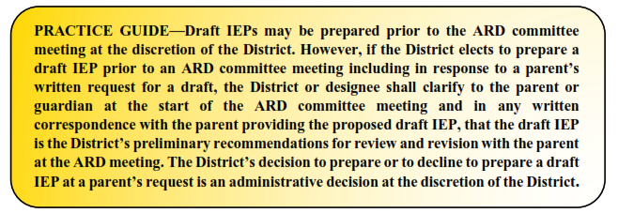
3.5 How does the District use Prior Written Notice (PWN) to inform parents about the decisions of a student’s ARD committee?

Prior Written Notice (PWN) shall include the following—

  - A description of the action proposed or refused by the District.
  - An explanation of why the District proposes or refuses to take an action.
  - A description of each evaluation procedure, assessment, record, or report the agency used as a basis for the proposed or refused action.
  - A statement that the parents of a student with a disability have protection under TEA’s Notice of Procedural Safeguards.
  - Sources for parents to contact to obtain assistance in understanding the provisions of a Prior Written Notice, such as the Education Service Center or TEA.
  - A description of other options that the ARD committee considered and the reasons why those options were rejected.
  - A description of other factors that are relevant to the District’s proposal or refusal.

Minutes or Deliberations. The written statement of an IEP shall document the decisions of the student’s ARD committee with respect to issues discussed at each ARD committee meeting or IEP Amendment. While deliberations are not required, the Big 4 SSA case manager shall ensure that the documents from an ARD committee meeting and the written statement of an IEP include the date of the meeting; the name, position, and signature of each member participating in the meeting; and an indication of whether the student's parents or guardians, the adult student, if applicable, and the administrator agreed or disagreed with the decisions of the committee.

- Documentation of the decisions of the student’s ARD committee may be done through preparation of ARD committee meeting deliberations or minutes. Prior Written Notice (PWN) shall be issued after each ARD committee meeting. A completed PWN would satisfy the District’s obligation to document the decisions of a student’s ARD committee. THROCKMORTON ISD may use the IEP and the deliberations or minutes as part of the PWN so long as the document(s) the parent or guardian receives meet all the requirements of prior written notice. The deliberations and/or the Prior Written Notice may be used to establish how the District is providing a FAPE to a student and collaborating with a parent or to document other factors relevant to a student’s IEP.

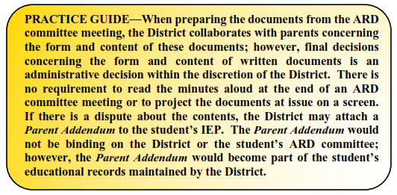

- IDEA does not require that the District include additional information in a student’s IEP beyond what is expressly required under 20 U.S.C. § 1414; 34 C.F.R. § 300.320 (d)(1). By way of example and not limitation, a student’s IEP does not need to include—
- The identity of specific teachers or specific educational methodology.
- Extracurricular activities unrelated to the student’s IEP.
- Services that are unrelated to the student’s special education program.

3.6 How does a student’s ARD committee make a placement decision?

To the maximum extent appropriate, students with disabilities must be educated with students who are nondisabled, and special classes, separate schooling, or other removal of students with disabilities from the general educational environment occurs only if the nature or severity of the disability is such that education in general education classes, with the use of supplementary aids and services, cannot be achieved satisfactorily. Once a student’s IEP is fully developed, the campus administrator shall ensure that the student’s ARD committee considers, and the student’s IEP documents, a placement determination based upon the individual needs of the particular student and the appropriate and least restrictive educational environment in which the IEP can be implemented. When making a placement decision, the campus administrator shall ensure that the ARD committee considers a continuum of alternative placements.

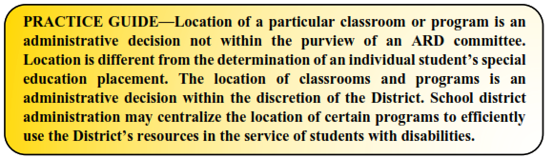

What does it mean to have a continuum of placement options for students? The District shall make available a continuum of alternative placements listed in the definition of special education under 34 C.F.R. § 300.38 (e.g., instruction in regular classes, special classes, special schools, home instruction, and instruction in hospitals and institutions), and make provision for supplementary services to be provided in conjunction with placement in the general education setting to facilitate such placement. The IEP, evaluations and other relevant data guide the ARD committee in making placement decisions.

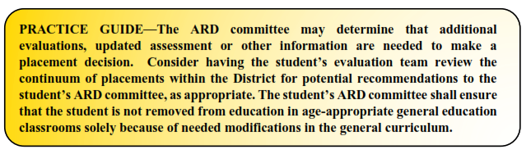

Before moving a student to a more restrictive environment, the student’s ARD committee shall consider ---
- Has the District taken steps to accommodate the student with disabilities in general education?

- Were these efforts sufficient or token?

- Will the student receive an educational benefit from general education?

- What will the student’s overall educational experience be in the general education environment, balancing the benefits of general and special education?

- What effect does the student’s presence have on the general education classroom environment?
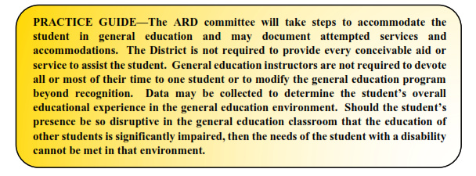

Residential Treatment Centers (RTCs) or private residential programs are included in the continuum of placements. The District is not required to place a student in a private residential program unless such placement is necessary to provide special education and related services. In order for a residential placement to be appropriate under the IDEA, the placement must be (1) essential in order for the student to receive a meaningful educational benefit, and (2) primarily oriented toward enabling the student to obtain an education. The District is not required to bear the costs of private residential services that are primarily aimed at treating a student’s medical difficulties or enabling the student to participate in non-educational activities.

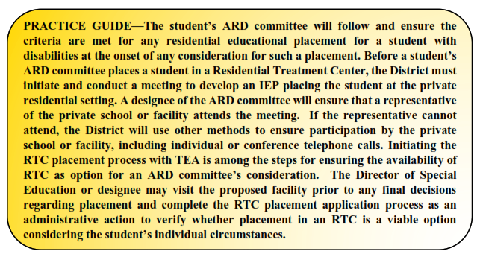

3.7 How does the District respond to a parent or guardian’s request for private placement when there is a disagreement regarding FAPE?

If the parents or guardians of a student with a disability, who previously attended the District, enroll the student in a private preschool, elementary school, or secondary school without the consent of or referral by the District, a court or a hearing officer may require the District to reimburse the parents for the cost of that enrollment if the court or hearing officer finds that the District had not made FAPE available to the student in a timely manner prior to that enrollment, and that the private placement is appropriate. The cost of reimbursement may be reduced or denied:

- if, at the most recent ARD committee meeting that the parents or guardians attended prior to removal of the student from the District, the parents or guardian did not inform the ARD committee that they were rejecting the placement proposed by the District to provide FAPE to the student, including stating their concerns and their intent to enroll the student in a private school at public expense;

- if, at least 10 District business days (including any holidays that occur on a business day) prior to the removal of the student from the District, the parents or guardians did not give written notice to the District that they were withdrawing the student and seeking reimbursement from the District for the cost of the private school placement;

- if, prior to the parents or guardians' removal of the student from the District, the District informed the parents or guardians, through the notice requirements described in these Operating Procedures, of its intent to evaluate the student (including a statement of the purpose of the evaluation that was appropriate and reasonable), but the parents did not make the student available for the evaluation; or

- if a hearing officer or judge finds that the parents acted unreasonably.
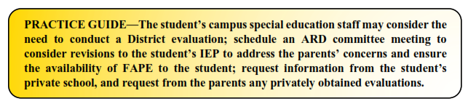

3.8 What happens if an ARD committee meeting ends in disagreement?

All members of the student’s ARD committee shall have the opportunity to participate in a collaborative manner when developing the student’s IEP. A decision of the ARD committee concerning the required elements of the student’s IEP should be made by mutual agreement, if possible. No decision is made by majority vote. If a student’s ARD committee cannot reach consensus, the Big 4 SSA case manager shall provide the parents with Prior Written Notice of the ARD committee’s proposals and/or refusals and the basis of the disagreement.

When mutual agreement about all required elements of the IEP is not achieved, the parent who disagrees shall be offered a single opportunity to recess and reconvene the ARD committee meeting. The period of time for reconvening the ARD committee meeting shall not exceed 10 school days, unless the parties mutually agree otherwise. The ARD committee shall schedule the reconvened meeting at a mutually agreed upon time and place.

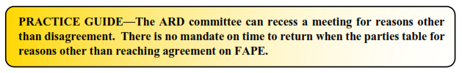

During the recess, the student’s ARD committee members shall consider alternatives for any disputed educational programming, gather additional data, prepare further documentation, and/or obtain additional resource persons who may assist in enabling the ARD committee to reach mutual agreement, if possible. The 10-day recess is not required when the student’s presence on the campus presents a danger of physical harm to the student or others or when the student has committed an expellable offense or an offense that may lead to placement in a DAEP.

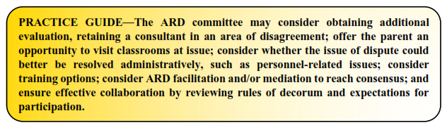

When mutual agreement is not reached, the Big 4 SSA case manager shall ensure that a written statement of the basis for the disagreement is thoroughly documented. Following Prior Written Notice, the District will implement the IEP that it has determined to be appropriate for the student.

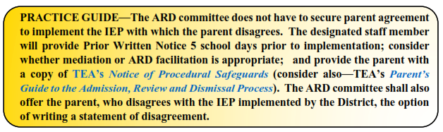
3.9 When and how is a student’s IEP updated?

In making changes to a student’s IEP after the annual ARD committee meeting for a school year, a parent or guardian and the District may agree not to convene an ARD committee meeting for the purpose of making those changes, and instead may develop a written document to amend or modify the student’s current IEP without a meeting. If changes are made to the student’s IEP by IEP Amendment without a meeting, the special education teacher and/or the Big 4 SSA case manager shall ensure that the student’s ARD committee and the individuals responsible for the implementation of the student’s IEP are informed of those changes. The Big 4 SSA case manager will provide the parent or guardian with Prior Written Notice of the amendments to the IEP. Upon request, a parent or guardian shall be provided with a revised copy of the IEP with the amendments incorporated.

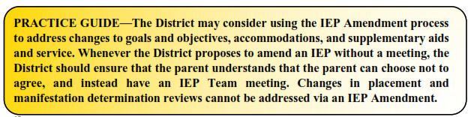
The student’s ARD committee shall review and revise the student’s IEP as follows:

- to periodically, but not less than annually, to determine whether the annual goals for the student are being achieved;

- to address any lack of expected progress toward the annual goals in the IEP and in the general education curriculum, if appropriate;

- to review the results of any reevaluation of the student or any information about the student provided to, or by, the parents or guardians, relevant to the student’s program of special education and related services; and

- to consider the student’s anticipated needs and other matters, as appropriate.

3.10 How does the District ensure parents or guardians are included in the IEP development process?

Each ARD committee shall endeavor to ensure that a student’s parent or guardian is included in the process of developing a student’s IEP.
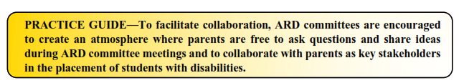
Each student’s special education teacher and/or Big 4 SSA case manager shall—

- Provide parents or guardians notice of all ARD committee meetings no later than 5 school days prior to each meeting (unless the parents or guardians agree to a shorter timeframe). In addition to the date and time of the meeting, each meeting notice shall include a list of all meeting participants known at the time the notice is provided to the parent or guardian; a brief description of the purpose of the meeting; and the mode of participation (e.g., in-person or via tele- or video conferencing). A meeting for which parental notice is required does not include informal or unscheduled conversations involving District personnel and conversations on issues such as teaching methodology, lesson plans, or coordination of service provision. A meeting also does not include preparatory activities that District personnel engage in to develop a proposal or response to a parent or guardian proposal that will be discussed at a later ARD committee meeting.

- Schedule ARD committee meetings with parents or guardians at a mutually agreed time and place.

- Document all efforts to schedule an ARD committee meeting with parents or guardians. If no parent or guardian can participate in an ARD committee meeting, the campus administrator and/or the Big 4 SSA case manager shall offer a parent or guardian the opportunity to participate in the meeting by tele- or video conferencing or other virtual means. The District may convene an ARD committee meeting without the involvement of a parent or guardian if the campus administrator and/or the Big 4 SSA case manager is unable to convince the parents or guardians that they should attend. Document and keep a record of attempts to arrange a mutually agreed upon time and place for the ARD committee meeting. These attempts may include—

  - Detailed records of telephone calls made or attempted and the results of those calls.

  - Copies of correspondence or e-mails sent to the parents or guardians and any responses received.

  - Detailed records of visits made to the parent or guardian's home or place of employment and the results of those visits.

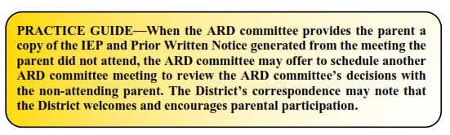

- Ensure and document receipt by the parent or guardian of a copy of the procedural safeguards notice at least once a year, and also

- Upon initial referral or parental request for evaluation.

- Upon the first occurrence of the filing of a due process hearing complaint.

- Following any disciplinary action requiring a manifestation determination review.

- At any other time on reasonable request of the student’s parent or guardian.

- Ensure that any education records, as defined by the District’s FL(LOCAL) policy, requested by a parent or guardian of a student with a disability may be inspected and reviewed by a parent or guardian or the parent or guardian’s representative (with informed written consent of the parent or guardian)—

- Before any ARD committee meeting.

- Before any mediation session or resolution session that is part of a special education due process hearing request.

- Without unnecessary delay but in no case more than 45 days.

Copies of educational records may be provided in accordance with the District’s FL(LOCAL) policy. Fees may be charged for those copies so long as the fee does not effectively prevent the parent or guardian from exercising their right to inspect and review the requested records.

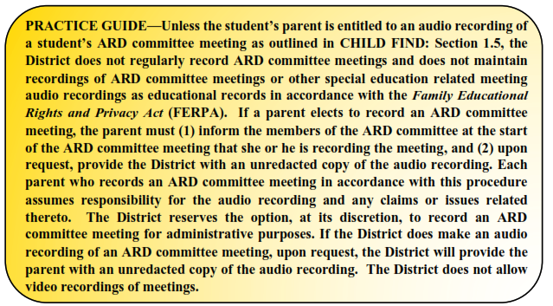
If a parent or guardian makes a written request for an ARD committee meeting, the District shall schedule the meeting as soon as appropriate under the circumstances, or within 5 school days provide a brief written explanation of why the District refuses to schedule the requested ARD committee meeting. When a parent or guardian makes a written request for an ARD committee meeting, the campus administrator and/or the Big 4 SSA case manager will provide the written explanation above or coordinate with the student’s parents, guardians, teachers and related service providers to schedule the ARD committee meeting.

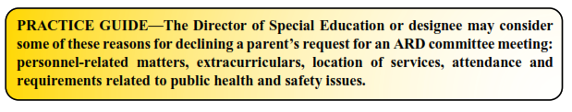

3.11 How does the District ensure that parents or guardians with emergent bilingual abilities are included in the IEP development process?

If the parent or guardian is one with emergent bilingual abilities and the parent or guardian’s native language is Spanish, the District will provide notices to the parent or guardian in Spanish. If the parent or guardian’s native language is other than English or Spanish, the District will make a good faith effort to provide notices to the parent or guardians in the parent or guardian’s native language unless it is clearly not feasible to do so. The term “native language” means the language normally used by the parent or guardian. Emergent Bilingual is equivalent to English Learner (EL) in the special education context.

If the parent or guardian is one with emergent bilingual abilities and the parent or guardian’s native language is Spanish, the District will provide at any ARD committee meeting a person who is able to interpret for the parent or guardian. If a parent or guardian’s native language is other than Spanish, the District will make a good faith effort to obtain an interpreter or translator to assist the parent or guardian. The campus administrator shall coordinate with the student’s
Big 4 SSA case manager to ensure that the parents or guardians of students with a disability whose native language is other than English are able to participate in the ARD committee meeting with the assistance of translators and interpreters, as appropriate. The Big 4 SSA case manager shall document these efforts in ARD committee documents and preserve in the student’s special education file all written correspondence or communications logs with parents or guardians and other individuals regarding the District’s efforts.

If the student's parent or guardian is unable to speak English and the parent or guardian's native language is Spanish, the District shall provide a written copy or audio recording of the student's IEP translated into Spanish. If the parent or guardian's native language is a language other than Spanish, the District shall make a good faith effort to provide the parent with a written copy or audio recording of the student’s IEP translated into the parent or guardian's native language. When translating a student’s IEP, all of the text in the student's IEP shall be accurately translated, resulting in a comparable rendition of the IEP in English and not a partial translation or summary.

3.12 How does the District ensure that a student’s IEP is implemented?

After the IEP is written and a placement is determined, the campus administrator shall coordinate with the student’s special and general education teachers and related service providers to ensure the student is provided the special education and related services identified in the IEP. The Big 4 SSA case manager shall make the student’s IEP accessible to each regular education teacher, special education teacher, related service provider, and any other service provider who is responsible for its implementation. Additionally, Big 4 SSA case manager shall inform each regular teacher, special education teacher, related service provider, and any other service provider who is responsible for the implementation of the student’s IEP, of each of her or his specific responsibilities related to implementation of the student’s IEP and the specific accommodations, modifications, and supports that must be provided for the student as identified in the IEP.

The Big 4 SSA shall maintain an eligibility folder for each student receiving special education services, in addition to the student's cumulative record. The eligibility folder shall include, but need not be limited to, copies of referral data; documentation of notices and consents; evaluation reports and supporting data; ARD committee reports; and the student's IEPs.

Each campus administrator and/or special education teacher shall ensure that each teacher who provides instruction to a student with disabilities:

- has access to the student's current IEP;
- is informed of the teacher's specific responsibilities related to implementation of the IEP, such as goals and objectives;
- is informed of needed accommodations, modifications, and supports for the student that must be provided for the student in accordance with the IEP; and
- has an opportunity to request assistance regarding implementation of the student's IEP.
Each district shall develop a process to be used by a teacher who instructs a student with a disability in a regular classroom setting to:
- request a review of the student's IEP; and
- provide input in the development of the student's IEP.
Each campus administrator shall timely respond to the teacher's request; and provide for notification to the student's parent or guardian of the teacher’s response.

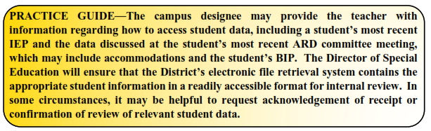
3.13 How does the District determine compensatory services for students whose FIIE was delayed or whose IEP was interrupted, reduced, delayed, suspended or discontinued during the 2019-2020 or 2020-2021 school years?

The Big 4 SSA case manager will ensure that the IEP for each student who was enrolled in the District’s special education program during the 2019-2020 or 2020-2021 school year, includes a written supplement that indicates whether that student’s FIIE was completed during the 2019-2020 or 2020-2021 school year, and if so, whether the report was completed by the date required. Big 4 SSA case manager will also, if applicable, indicate whether the student’s initial IEP was developed by the date required by EVALUATIONS: section 2.4. Big 4 SSA case manager will also indicate whether the provision of special education services to that student under an IEP during the 2019-2020 or 2020-2021 school year was interrupted, reduced, delayed, suspended, or discontinued.
Based on these or any other factors, the ARD committee will determine and document whether compensatory educational services are appropriate for the student.

3.14 How does the District ensure adult students are included in the IEP development process?

At least one year before a student with a disability turns 18, the Big 4 SSA case manager shall ensure that the student’s IEP contains a statement regarding the transfer of special education rights and responsibilities at the age of 18. The student’s IEP shall also state that the student has been provided information and resources regarding guardianship, alternatives to guardianship, including a supported decision-making agreement and other supports and services that may enable the student to live independently. When the student turns 18, the Big 4 SSA case manager shall notify the adult student and her or his parent or guardian of the transfer of parental rights, and shall begin sending both the parent or guardian and student any notice required in these Operating Procedures.

3.15 What happens when a student with an IEP graduates with a regular high school diploma?

Graduation from the District with a regular high school diploma terminates a student's eligibility to receive special education and related services. A student who receives special education services may graduate and be awarded a regular high school diploma if the student has demonstrated mastery of the required state standards (or district standards, if greater) and completed credit requirements (for graduation under the Foundation High School Program) specified in the Foundation High School Program that are applicable to students in general education, as well as satisfactory performance on the required state assessments, unless the student's ARD committee has determined that satisfactory performance on the required state assessments is not necessary for graduation.

The campus administrator shall ensure that whenever a student’s eligibility for special education and related services is terminated through receipt of a regular high school diploma or because the student no longer meets age eligibility requirements for special education and related services, the Big 4 SSA case manager shall provide the student a written summary of the student’s then-present level of academic achievement and functional performance. This summary must consider, as appropriate, the views of the parent or guardian and student, and written recommendations from adult service agencies on how to assist the student in meeting postsecondary goals. An evaluation or REED shall be included as part of the summary.

For students who receive a diploma based upon successful completion of the IEP and other relevant factors, the ARD committee shall determine needed educational services upon the request of the student or the student’s parent or guardian to resume services, as long as the student meets the age eligibility requirements set out in CHILD FIND: Section 1.2 above.

3.16 What are the District’s obligations to children transitioning from IDEA Part C Early Intervention Services (EIS) to IDEA Part B Early Childhood Special Education (ECSE)?

THROCKMORTON ISD coordinates with Texas Health and Human Services Commission (THHSC) or its local designees—the Early Intervention Agency—to notify parents or guardians of children in the District who are at least 3 years of age but younger than 6 years of age and who are potentially eligible for enrollment in THROCKMORTON ISD’s IDEA Part B Early Childhood Special Education (ECSE) program of the availability of the program. Additionally, at least 90 days before the 3rd birthday of a child with a disability under Part C EIS, who may be eligible for preschool special education and related services under Part B, the Early Intervention Agency—must notify the District that the child will shortly reach the age of eligibility for THROCKMORTON ISD’s ECSE program. The Big 4 SSA office is an appropriate contact to receive such notice.

If a child is potentially eligible for THROCKMORTON ISD’s ECSE program, with family approval, a transition conference will be convened by the Early Intervention Agency, with an invitation to the District, not fewer than 90 days and not more than 9 months before the child’s 3rd birthday, to discuss any potential special education and related services the child could receive from the District.

If the Early Intervention Agency determines that the child is eligible for Early Intervention Services (EIS) more than 45 but less than 90 days before the child’s 3rd birthday and if that child may be eligible for ECSE services under Part B, the Early Intervention Agency, as soon as possible after determining the child's eligibility, must notify THROCKMORTON ISD that the child on his 3rd birthday will reach the age of eligibility for the District’s ECSE program.
The Big 4 SSA office is an appropriate contact to receive such notice.

The Big 4 SSA case manager shall ensure that an IEP is in effect for an IDEA B eligible child with a disability who had previously received IDEA Part C services by the child’s 3rd birthday while complying with the procedures in EVALUATIONS: Section 2.0 above. If a child's 3rd birthday occurs during the summer, the student's ARD committee shall determine the date when services will begin.

If THROCKMORTON ISD knows that a child served in Part C via an Individualized Family Service Plan (IFSP) developed by the Early Intervention Agency and referred to IDEA Part B will turn 3 over the summer and that appropriate THROCKMORTON ISD personnel won't be available to conduct evaluations and hold ARD committee meetings during the summer, the Big 4 SSA case manager shall ensure that required activities such as conducting the evaluations, and convening the ARD committee meeting occurs before the end of the school year.

When the Early Intervention Agency provides notification to THROCKMORTON ISD of a potentially eligible child fewer than 90 days before the student’s 3rd birthday, the Early Intervention Agency must provide a written explanation to the District stating the reason for the delay.
The Big 4 SSA office is an appropriate contact to receive such notice. If notification is given between 45-89 days before the student’s 3rd birthday, Big 4 SSA case manager shall ensure that eligibility is determined as soon as possible.

If a student with a disability was served under IDEA Part C via an IFSP, the student’s IFSP may serve as the IEP of a child with a disability aged 3 through 5 (or, at the discretion of the state educational agency, a 2-year-old child with a disability who will turn age 3 during the school year), if the IFSP was developed in accordance with ARD committee procedures, is consistent with state policy, and agreed to by THROCKMORTON ISD and the student's parents or guardians.

If a student’s IFSP was incorrectly developed by the Early Intervention Agency and THROCKMORTON ISD and the parent or guardian agree to use the IFSP in lieu of an IEP, THROCKMORTON ISD shall modify the IFSP so that it meets the requirements for an IEP.

While IDEA Part B requires coordination to assure the continuity of services, it does not compel THROCKMORTON ISD to provide all the same services in an IEP that were in a student’s IFSP.

3.17 Are there limitations on the right to FAPE?

If the parent of a student enrolled in THROCKMORTON ISD or is seeking to be enrolled in the District does not provide consent for the student’s full individual and initial evaluation, or the parent fails to respond to a request to provide consent, THROCKMORTON ISD may, but is not required to, pursue the initial evaluation of the child by utilizing the procedural safeguards under IDEA.
THROCKMORTON ISD will use reasonable efforts to obtain parental consent. THROCKMORTON ISD will also document its efforts to obtain parental consent, and maintain such documentation in the student’s special education file. The level of effort shall be appropriate to the situation. The actions of THROCKMORTON ISD when seeking parental consent will reflect genuine effort and will include more than one effort or means. If the parent or guardian does not provide consent for the student’s full individual and initial evaluation after the District has requested and sought to obtain such consent, the District does not violate its Child Find and FAPE obligations to the student if the District declines to pursue the evaluation under these circumstances by requesting a due process hearing to override the parent’s lack of consent.

The THROCKMORTON ISD shall obtain informed consent from the parent or guardian of a student before the initial provision of special education and related services to the student. THROCKMORTON ISD will not construe consent for initial evaluation as consent for initial provision of special education and related services. The Big 4 SSA case manager shall make reasonable efforts to obtain informed consent from the parent or guardian for the initial provision of special education and related services; however, if the parent or guardian fails to respond to a request for, or refuses to consent to, the initial provision of special education and related services, THROCKMORTON ISD cannot seek to override the parent’s refusal to consent to the initial provision of special education and related services to the student. If the parent does not provide informed written consent for the initial provision of special education and related services, THROCKMORTON ISD will not be considered to be in violation of the requirement to make FAPE available to the student because of the failure to provide the student with the special education and related services for which the parent refuses to or fails to provide consent. THROCKMORTON ISD is also not required to convene an ARD committee meeting or develop an IEP for the student.

If, at any time subsequent to the initial provision of special education and related services, the parent or guardian of a student revokes consent in writing for the continued provision of special education and related services, THROCKMORTON ISD:

- may not continue to provide special education and related services to the student, but shall provide Prior Written Notice, including TEA’s Notice of Procedural Safeguards, before ceasing the provision of special education and related services;

- may not use the dispute resolution procedures in IDEA in order to obtain agreement or a ruling that the services may be provided to the student;

- will not be considered to be in violation of the requirement to make FAPE available to the student because of the failure to provide the student with further special education and related services; and

- is not required to convene an ARD committee meeting or develop an IEP for further provision of special education and related services.
Unless a parent or guardian has enrolled a student in private school as described in Section 3.6, above, that student’s enrollment in a private school relieves THROCKMORTON ISD of any responsibility for the provision of a FAPE, but the student may be considered for proportionate share services. Likewise, students attending a homeschool program are not entitled to FAPE but may be considered for proportionate share services. TEA, and therefore THROCKMORTON ISD, does not regulate, index, monitor, approve, register, or accredit the programs available to parents who choose to home school. This is consistent with the Texas Supreme Court decision rendered in Texas Education Agency v. Leeper.

3.18 How does the District provide FAPE via virtual or remote instruction?

In accordance with guidance from the TEA, each student’s Big 4 SSA case manager is encouraged to offer to convene ARD committee meetings to develop emergency contingency plans as part of a student’s IEP that provides for virtual or other remote services and instruction during periods of cessation of normal school operations in response to a natural disaster, pandemic and/or other public health and safety crisis in accordance with federal, state and local authorities. A student’s Big 4 SSA case manager may also propose that a student’s ARD committee and the parent(s) or guardian(s) agree to modify a student’s IEP to include a separate schedule of related services and accommodations that will be followed during periods of remote or virtual instruction. Big 4 SSA together with input from the parent or guardian and the student’s ARD committee, may choose to use the model Special Education Emergency Contingency Plan developed by the TEA or other plan as determined by the District.

According to nonbinding guidance from OSEP on September 28, 2020, ARD committees should consider—
- “how a student's IEP will be implemented with traditional in-person instruction

- how services also could be provided through remote/distance instruction if circumstances require a change to distance learning or a hybrid model.”
When ARD committees make these determinations, the ARD committee, together with the parent or guardian, may also consider:

- alternate available instructional methodologies or delivery;

- online instruction, teleconference, direct instruction via telephone or videoconferencing; and

- consultative services to the parent, if feasible and appropriate.
The Big 4 SSA evaluation personnel will investigate all appropriate assessment instruments and tools to determine if some can be administered or completed remotely during the natural disaster, pandemic and/or other public health and safety crisis, provided that evaluation of the student is based on personal observation (whether in person or through tele- or videoconferencing).

The Big 4 SSA evaluation personnel may coordinate with the developers of their current assessment instruments to determine if the instruments can be administered or completed remotely, without significantly impacting the validity and reliability of the results. Tests and other evaluation materials must be used for the purposes for which the assessments or measures are valid and reliable, and must be administered by trained and knowledgeable personnel in accordance with any instructions provided by the producer of the assessments.

34 C.F.R. § 300.17; Endrew F. ex rel. Joseph F. v. Douglas County School Dist. RE-1, 137 S.Ct. 988 (2017); E.R. v. Spring Branch Indep. Sch. Dist., 909 F.3d 754 (5th Cir. 2018).
Cypress-Fairbanks Indep. Sch. Dist. v. Michael F., 118 F.3d 245 (5th Cir.1997).
19 TEX. ADMIN. CODE § 89.1050(a)
34 C.F.R. § 300.321 (a); 19 TEX. ADMIN. CODE § 89.1050(c)
34 C.F.R. § 300.327
U.S. Dept. of Education, 71 Fed. Reg. 46669 (August 14, 2006) (“[i]t would be inappropriate to require that individuals with specific professional knowledge or qualifications attend all IEP Team meetings. These decisions should be made on a case-by-case basis in light of the needs of a particular child”).
U.S. Dept. of Education, 71 Fed. Reg. 46669 (August 14, 2006)
U.S. Dept. of Education, 71 Fed. Reg. 46670 (August 14, 2006)
Id.
US Department of Education, 71 Fed. Reg. 46673 (August 14, 2006)
Id.
Id.
OSEP’s Letter to Andel (February 17, 2016)( “[i]t would be permissible for the public agency to reschedule the meeting to another date and time if the parent agrees so long as the postponement does not result in a delay or denial of a free appropriate public education to the child”).
19 TEX. ADMIN. CODE § 89.1011(d)
34 C.F.R. § 300.324(a)-(b)
19 TEX. ADMIN. CODE 89.1050(j)(4)
34 C.F.R. § 300.3232(e)
19 TEX. ADMIN. CODE 89.1050(j)(1)
34 C.F.R. § 300.323(f)
34 C.F.R. § 300.323(f)(1)
19 TEX. ADMIN. CODE § 89.1050(j)(2)
34 C.F.R. § 300.323(f)(2)
19 TEX. ADMIN. CODE § 89.1050(j)(2)
19 TEX. ADMIN. CODE § 89.1050(j)(2)
Id.
34 C.F.R. § 300.324(a)(1)(ii)
34 C.F.R. § 300.324(a)(1)(i), (iii)
34 C.F.R. § 300.502(c)(1)
U.S. Dept. of Education, 71 Fed. Reg. 46577 (August 14, 2006)(“§ 300.320(a)(2)(i) requires annual IEP goals to be designed to enable the child to be involved in and make progress in the general education curriculum”)
34 C.F.R. § 300.320(a); 34 C.F.R. § 300.324(a)(1)(iv).
Tex. Ed. Code § 39.0263
34 C.F.R. § 300.320
E.R. v. Spring Branch Indep. Sch. Dist., 909 F.3d 754 (5th Cir. 2018).
34 C.F.R. § 300.42; 34 C.F.R. § 300.320
34 C.F.R. § 300.324(a)(2)(i)
34 C.F.R. § 300.324(a)(2)(i)
Alex R. v. Forestville Valley Community Unit School District, 375 F.3d 603 (7th Cir. 2004)
Tex. Ed. Code § 29.005(g)
Tex. Ed. Code § 29.005(h)
Id.
34 C.F.R. § 300.320; 34 C.F.R. § 300.38(b)(3)
34 C.F.R. §300.39(a)(1)
34 C.F.R. §300.39(b)(3)(emphasis added)
The educational standards applicable to all children in the state of Texas are also outlined in Tex. Ed. Code § 28.002 and in 19 TEX. ADMIN. CODE § 74.1.
34 C.F.R. § 300.320(a)(4)(iii).
34 C.F.R. § 300.320
34 C.F.R. § 300.34(a)
U.S. Department of Education, 71 Fed. Reg. 46667(2006)
19 TEX. ADMIN. CODE § 89.1055(h)
34 C.F.R. § 300.320(b)(1); U.S. Department of Education, 71 Fed. Reg. 46668 (2006)
19 TEX. ADMIN. CODE § 89.1065 ; Alamo Heights ISD v. State Board of Ed., 790 F2d. 1153 (5th Cir. 1986)(severe or substantial regression required for ESY).
OSEP. Part B Implementation of IDEA Provision of Services in the Current COVID-19 Environment Q&A Document. September 28, 2020.
Tex. Ed. Code § 37.001(b-1)
US Department of Education, 71 Fed. Reg. 46678 (2006)(“[w]e do not encourage public agencies to prepare a draft IEP prior to the IEP Team meeting, particularly if doing so would inhibit a full discussion of the child's needs. However, if a public agency develops a draft IEP prior to the IEP Team meetings, the agency should make it clear to the parents at the outset of the meeting that the services proposed by the agency are preliminary recommendations for review and discussion with the parents”; White ex rel. White v. Ascension Parish School Board, 343 F.3d 373 (5th Cir. 2003).
34 C.F.R. § 300.503(b)
Tex. Ed. Code § 29.005(b-1)
U.S. Department of Education, 71 Fed. Reg. 46691 (August 14, 2006)
Letter to Hall, 21 IDELR 58 (OSERS 1994).
Letter to Anonymous, 17 IDELR 180 (OSEP 1990).
Letter to Montano, 18 IDELR 1232 (OSEP 1992).
A.B. v. Clear Creek ISD, 75 IDELR, 787 F.App’x 217 (5th Cir. 2019); Daniel RR v. State Bd. of Ed., 874 F.2d 1036 (5th Cir. 1989); J.H. v. Fort Bend Indep. Sch. Dist., 482 Fed. Appx. 915 (5th Cir. 2012)
34 C.F.R. § 300.114 (a)
White ex rel. White v. Ascension Parish School Board, 343 F.3d 373 (5th Cir. 2003).
34 C.F.R. § 300.115(b); 34 C.F.R. § 300.115(b); 19 TEX. ADMIN CODE §89.1005
34 C.F.R. § 300.116(e)
Daniel RR v. State Bd. of Ed., 874 F.2d 1036 (5th Cir. 1989)
34 C.F.R. § 300.115
Richardson ISD v. Michael Z, 580 F.3d 286 (5th Cir. 2009); 34 C.F.R. § 300.104
Tex. Ed. Code § 29.008; Tex. Ed. Code § 29.012; 19 TEX. ADMIN. CODE § 89.61; 34 C.F.R. § 300.325(a)
School Comm. of Burlington v. Department of Educ. of Mass., 471 U.S. 359, 369 (1985); see also, 34 C.F.R. 300.148(c); Forest Grove Sch. Dist. v. T.A., 557 U.S. 230, 129 S. Ct. 2484, 2496 (2009)
19 TEX. ADMIN. CODE § 89.1050(g)
19 TEX. ADMIN. CODE § 89.1050(g)(1)
19 TEX. ADMIN. CODE § 89.1050(g)(2)
Id.
19 TEX. ADMIN. CODE § 89.1050(g)(1)
19 TEX. ADMIN. CODE § 89.1050(g)(3)
19 TEX. ADMIN. CODE § 89.1050(g)(4) ; TEA’s Notice of Procedural Safeguards; Parent’s Guide to the Admission, Review and Dismissal Process
OSERS, Questions and Answers on Individualized Education Programs (IEPs), Evaluations, and Reevaluations. Revised September 2011.
34 C.F.R. § 300.324(a)(6)
US Department of Education, 71 Fed. Reg. 46685 (August 14, 2006).
34 C.F.R. § 300.324
Buser v. Corpus Christi Indep. Sch. Dist., 51 F.3d 490 (5th Cir. 1995); White v. Ascension Parish, 343 F.3d 373 (5th Cir. 2013) (IDEA requirements with respect to parental input are met “[a]bsent any evidence of bad faith exclusion of the parents or refusal to listen to or consider” parental input); 19 TEX. ADMIN. CODE § 89.1050(e); 34 C.F.R. § 300.503.
Rockwall ISD v. M.C., 816 F.3d 329 (5th Cir. 2016); Cypress-Fairbanks Indep. Sch. Dist. v. Michael F., 118 F.3d 245 (5th Cir.1997).
19 TEX. ADMIN. CODE § 89.1050(d)
34 C.F.R. § 300.501(b)(3)
34 C.F.R. § 300.322(a)(2)
34 C.F.R. § 300.501(c)
34 C.F.R. § 300.322(d)
89 34 C.F.R. 300.504(a)
90 34 C.F.R. 300.504(a)(1)
91 34 C.F.R. 300.504(a)(2)
92 34 C.F.R. 300.504(a)(3)
93 34 C.F.R. 300.504(a)(4)
34 C.F.R. § 300.613
34 C.F.R. § 300.617 (The District may not charge a fee to search for or to retrieve the educational records.)
“IDEA does not address the use of audio or video recording devices at IEP meetings, and no other Federal statute either authorizes or prohibits the recording of an IEP meeting by either a parent or a school official. Therefore, [the District] has the option to require, prohibit, limit or otherwise regulate the use of recording devices at IEP meetings.” OSEP 2003.
19 TEX. ADMIN. CODE § 89.1050(e); Tex. Ed. Code § 29.005(c)
20 U.S.C. § 1401(20)
34 C.F.R. § 300.27
34 C.F.R. § 300.322(e)
19 TEX. ADMIN. CODE § 89.1050(i); Tex. Ed. Code § 29.005(d)
19 TEX. ADMIN. CODE § 89.1050(i)(1)
34 C.F.R. § 300.323(c)
34 C.F.R. § 300.323(d)
Id.
19 TEX. ADMIN. CODE § 89.1075(a)
19 TEX. ADMIN. CODE § 89.1075(c)
19 TEX. ADMIN. CODE § 89.1075(d)
19 TEX. ADMIN. CODE § 89.1075(c)
Tex. Ed. Code § 29.0052(a)(1)
Tex. Ed. Code § 29.0052(b)
Tex. Ed. Code § 29.0052(a)(2)
Tex. Ed. Code § 29.0052(a)(3)
Tex. Ed. Code § 29.0052(a)(4)
“Other considerations [when addressing the adverse impact of caused by COVID-19] could include, but are not limited to, revising the IEP to address (1) lost skills or a lack of expected progress toward attaining the child’s annual IEP goals and in the general curriculum at the end of the 2020–2021 school year; (2) updated data (e.g., information gathered from formal and informal assessments, parent input) that reflect the child’s present levels of academic achievement and functional performance following the extended time without face-to-face, in-person special education and related services; (3) all areas of need, whether or not commonly related to the child’s disability category, or if the child may require different or other services to address new areas of need (e.g., behavioral, social, emotional, and mental health needs, needs that arose during the pandemic); and (4) implementing COVID-19 prevention measures such as wearing a face covering/mask or practicing social distancing to provide a safe and healthy school environment and safe participation in the community.” Return to School Roadmap: Development and Implementation of Individualized Education Programs In the Least Restrictive Environment Under the Individuals with Disabilities Education Act, OSERS, October 2021.
19 TEX. ADMIN. CODE § 89.1049
19 TEX ADMIN. CODE § 89.1070(a)
19 TEX. ADMIN. CODE § 89.1070(b)(1)
19 TEX. ADMIN. CODE § 89.1070(g)
19 TEX. ADMIN. CODE § 89.1070(j)
34 C.F.R. § 303.22
Tex. Ed. Code § 29.009
34 C.F.R. § 303.209(b)(1)(i); Early Childhood Transition FAQs (OSEP 2009).
34 C.F.R. § 303.209 (b)(1)(ii).
34 C.F.R. § 300.101
Early Childhood Transition FAQs (OSEP 2009)
34 C.F.R. § 300.323 (b)(1); 20 USC § 1414 (d)(2)
34 C.F.R. § 300.323 (b); U.S. Department of Education, 71 Fed. Reg. 46679 (2006)
34 C.F.R. § 300.300(a)(3)
34 C.F.R. § 300.300(b)(3)
34 C.F.R. § 300.300(b)(4)
19 TEX. ADMIN. CODE § 89.1096
Texas Education Agency v. Leeper, 893 S.W.2d 432 (Tex. 1994)
OSEP. Part B Implementation of IDEA Provision of Services in the Current COVID-19 Environment Q&A Document. September 28, 2020.
Id.
34 C.F.R. § 300.304(c)(l)(iii)-(v)

